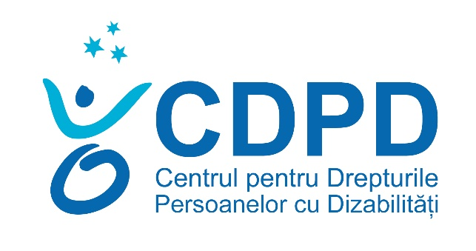
Centre for the Rights of Persons with Disabilities

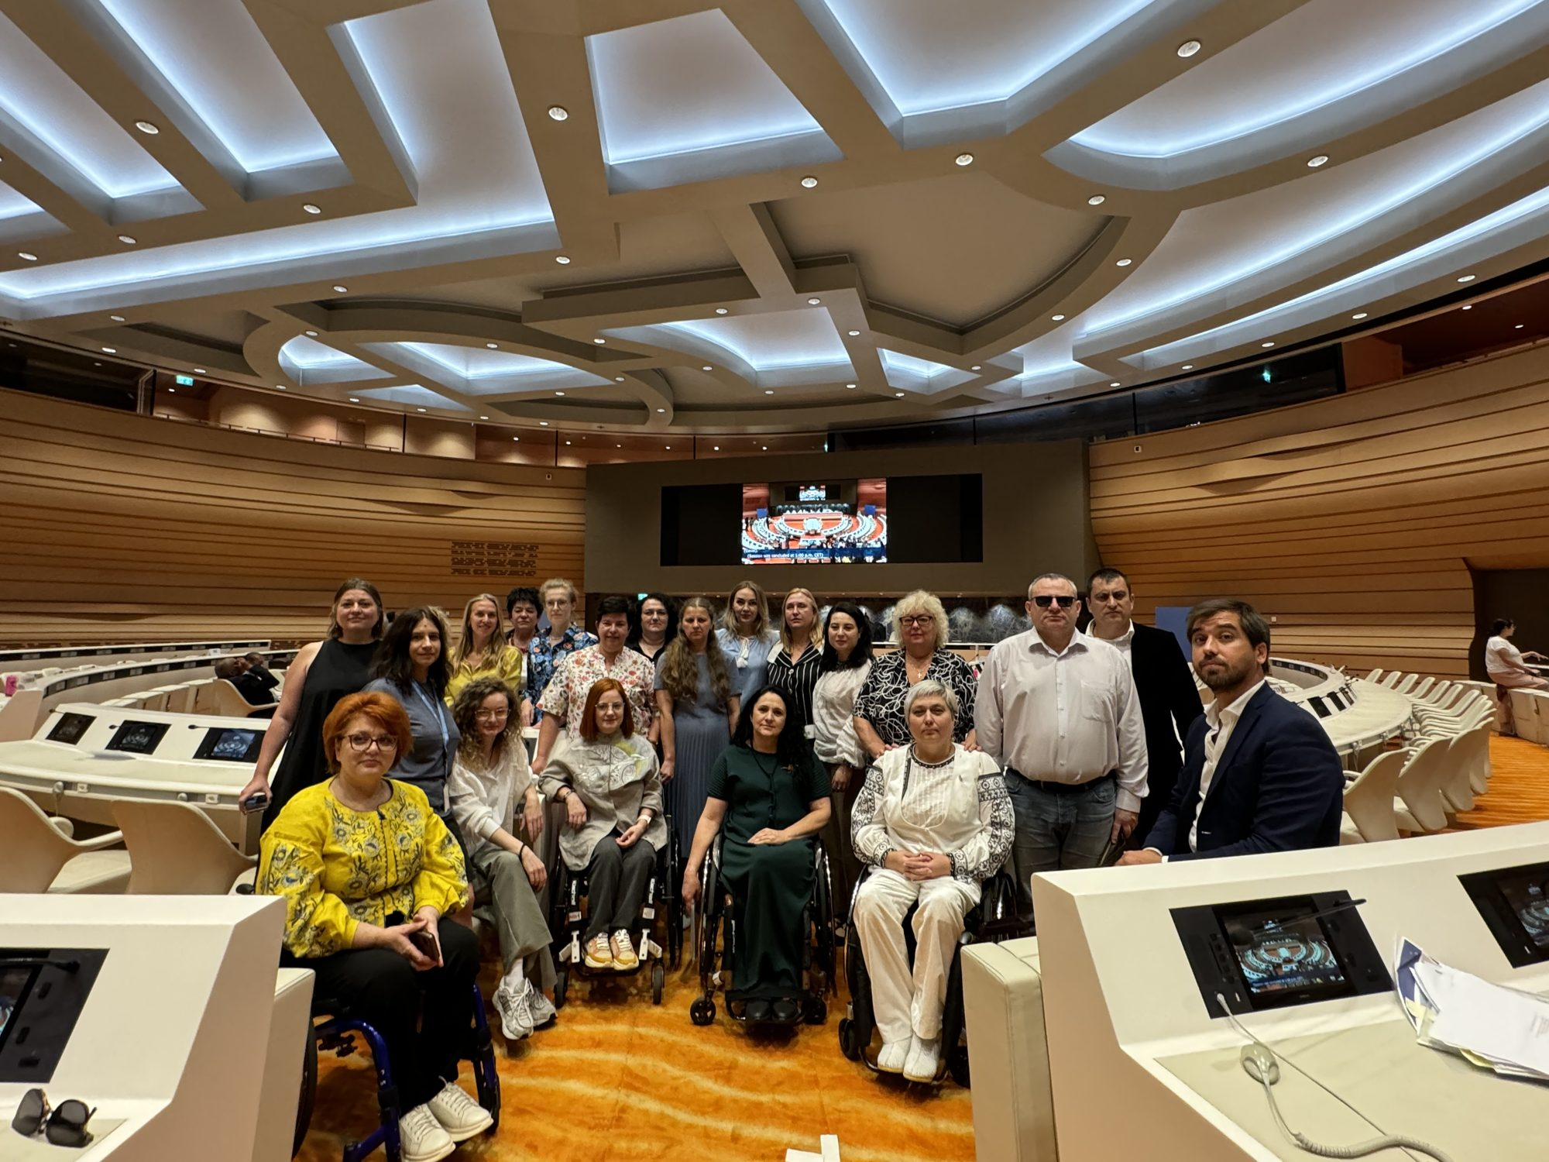
ACTIVITY REPORT
2024


Institutional partner IM SDP

The vision of the association is comprised in our commitment to contribute to the creation of an inclusive society in which all men and women, boys and girls with disabilities in the Republic of Moldova, without discrimination, enjoy respect for their human dignity.
Our mission is to promote and protect the rights of persons with disabilities, without distinction of race, colour, nationality, ethnic origin, language, religion or belief, gender, sex, age, opinion, political affiliation or any other similar criterion, to favour social inclusion and their spiritual fulfilment through monitoring actions, advocacy and programs to develop their potential.

Values
CRPD creates partnerships for an inclusive society for all, following the principle of respect for Human Dignity.
- Love for others: the most important call is to value and care for people;
- Integrity: consistency, honesty, fairness and transparency – assessed by the accuracy of our actions;
- Excellence: we are committed to the highest professional standards;
- Family: we value the balance between family, personal and professional development;
- Equal opportunities: we contribute to everyone's full participation in public life.
Strategic objectives
• Facilitating the gradual adjustment of national legislation and public policies to the provisions of the UN Convention on the Rights of Persons with Disabilities
• Defending the rights of persons with disabilities
• Economic empowerment of persons with disabilities
• Participation in political and public life of persons with disabilities.
Areas of expertise:
- Advocacy for the promotion of the rights of persons with disabilities.
- Strategic litigation for the defence of the rights of persons with disabilities.
- Monitoring compliance with the rights of persons with disabilities.
- Analysis of public policies in the field of the rights of persons with disabilities in the light of international standards in the field of human rights.
- Participation in political and public life of persons with disabilities.
- Physical and informational accessibility according to the concept of universal design.
- Protection against discrimination of persons with disabilities.

CRPD programs implemented in 2024
- RIGHTS OF PERSONS WITH DISABILITIES
- ADVOCACY FOR PUBLIC POLICIES SENSITIVE TO THE NEEDS OF PERSONS WITH DISABILITIES
- CDPD'S RESPONSE TO THE HUMANITARIAN CRISIS CAUSED BY THE WAR IN UKRAINE.
- SOCIAL ENTREPRENEURSHIP, ECONOMIC EMPOWERMENT AND SUPPORTED EMPLOYMENT
- ORGANIZATIONAL DEVELOPMENT

    - RIGHTS OF PERSONS WITH DISABILITIES
Gheorghe Bosii, Program Director
Partners/Funders: IM SDP, UNDP, NRC, EDF, CBM.
The activities were carried out in accordance with the CRPD Operational Plan for 2024, the following priority directions of activity were foreseen.

COMPONENT 1: LEGAL AID
1.2. Providing legal aid
In 2024, the CRPD provided legal assistance to 915 people, of which 650 women and 265 men.
734 - beneficiaries of primary legal assistance;
181 - beneficiaries of qualified legal assistance;
455 – requests, petitions, complaints, notifications, requests to challenge court decisions, etc. drawn up in the name and in the interest of the beneficiaries, addressed to public authorities, as well as to other institutions, organizations.
99 - participation of CRPD representatives in court hearings and equality council for the purpose of defending persons with disabilities as well as cases of public interest.
Legal assistance was also provided to 11 NGOs: Elșadai Association, Federation of Visually Impaired Athletes, Neemia Association, ANM, Dolna Association, ASRM, INFONET Alliance, Sunshine, SOS AUTISM, Automobil Club Moldova, Association for the Protection of Persons with Disabilities.

  - Public Lessons
115 public lessons, information workshops, held in of/online format, were held, during which 1725 people were informed on various topics related to the field of persons with disabilities, including the rights of persons with disabilities and refugees from Ukraine.

1.3. Advocacy on improving access to justice for persons with disabilities
Within the partnership between the CDPD, the INFONET Alliance and UNIVERSAL ACCES SRL – (Social Enterprise), 45 web pages of the authorities in the field of justice (including the courts) were evaluated in terms of accessibility.
In order to increase the degree of physical and informational accessibility of the headquarters of the courts, CRPD, in partnership with the INFONET Alliance and other NGOs in the field, carried out the evaluation of 50 buildings of the courts, authorities and public courts in the field of justice. https://www.infonet.md/?p=8430
1.4. Development of the network of paralegals in the Transnistrian region of the Republic of Moldova
During 2024, CRPD, in partnership with the organizations active in the field of the rights of persons with disabilities operating on the left bank of the Dniester, namely NGO "Sociohab", AO "VIALEX", AO "GLIN", AO "Алые паруса", AO "От равного к равному", in consultation with CNAJGS, the roadmap aimed at developing the network of paralegals in the Transnistrian region of the Republic of Moldova was developed. https://shorturl.at/VSb3v
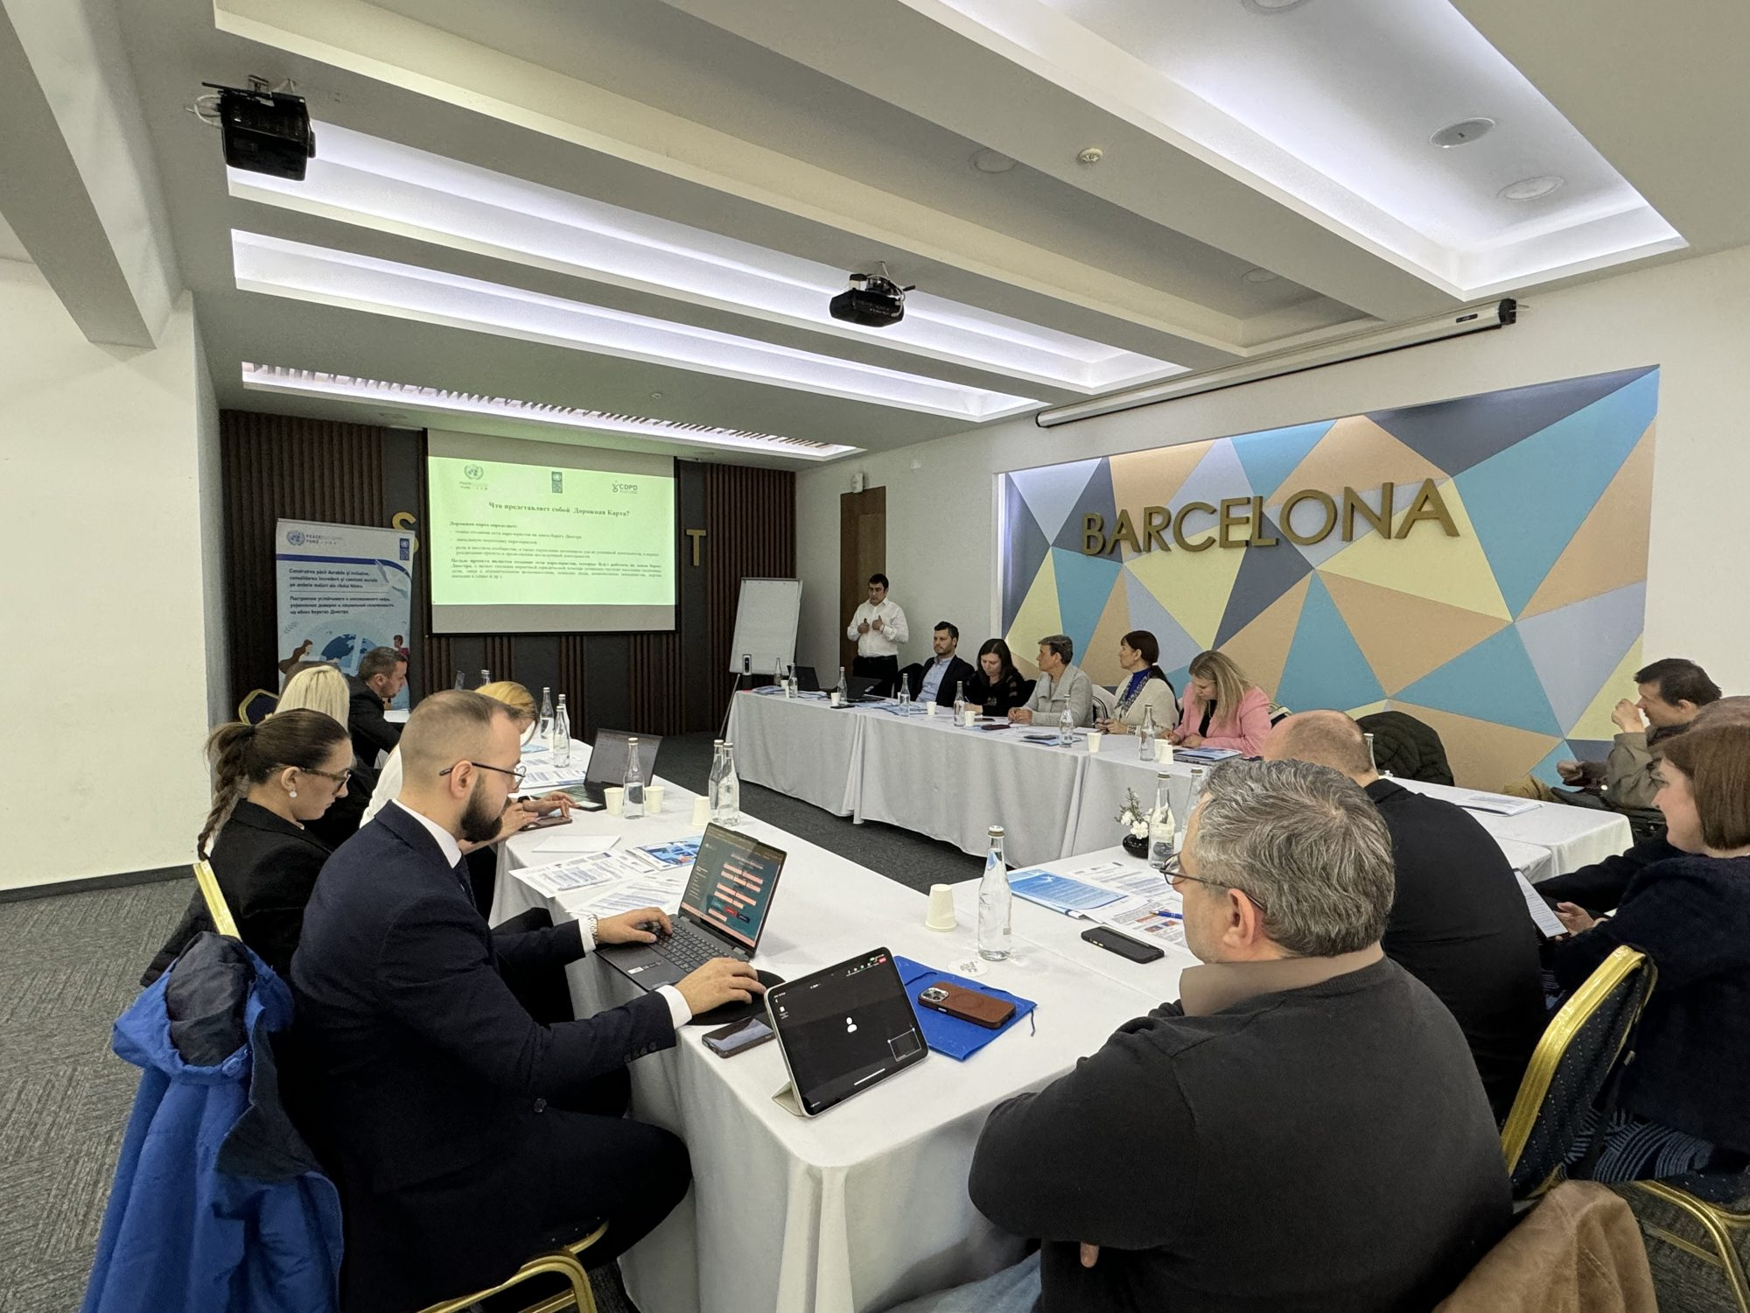
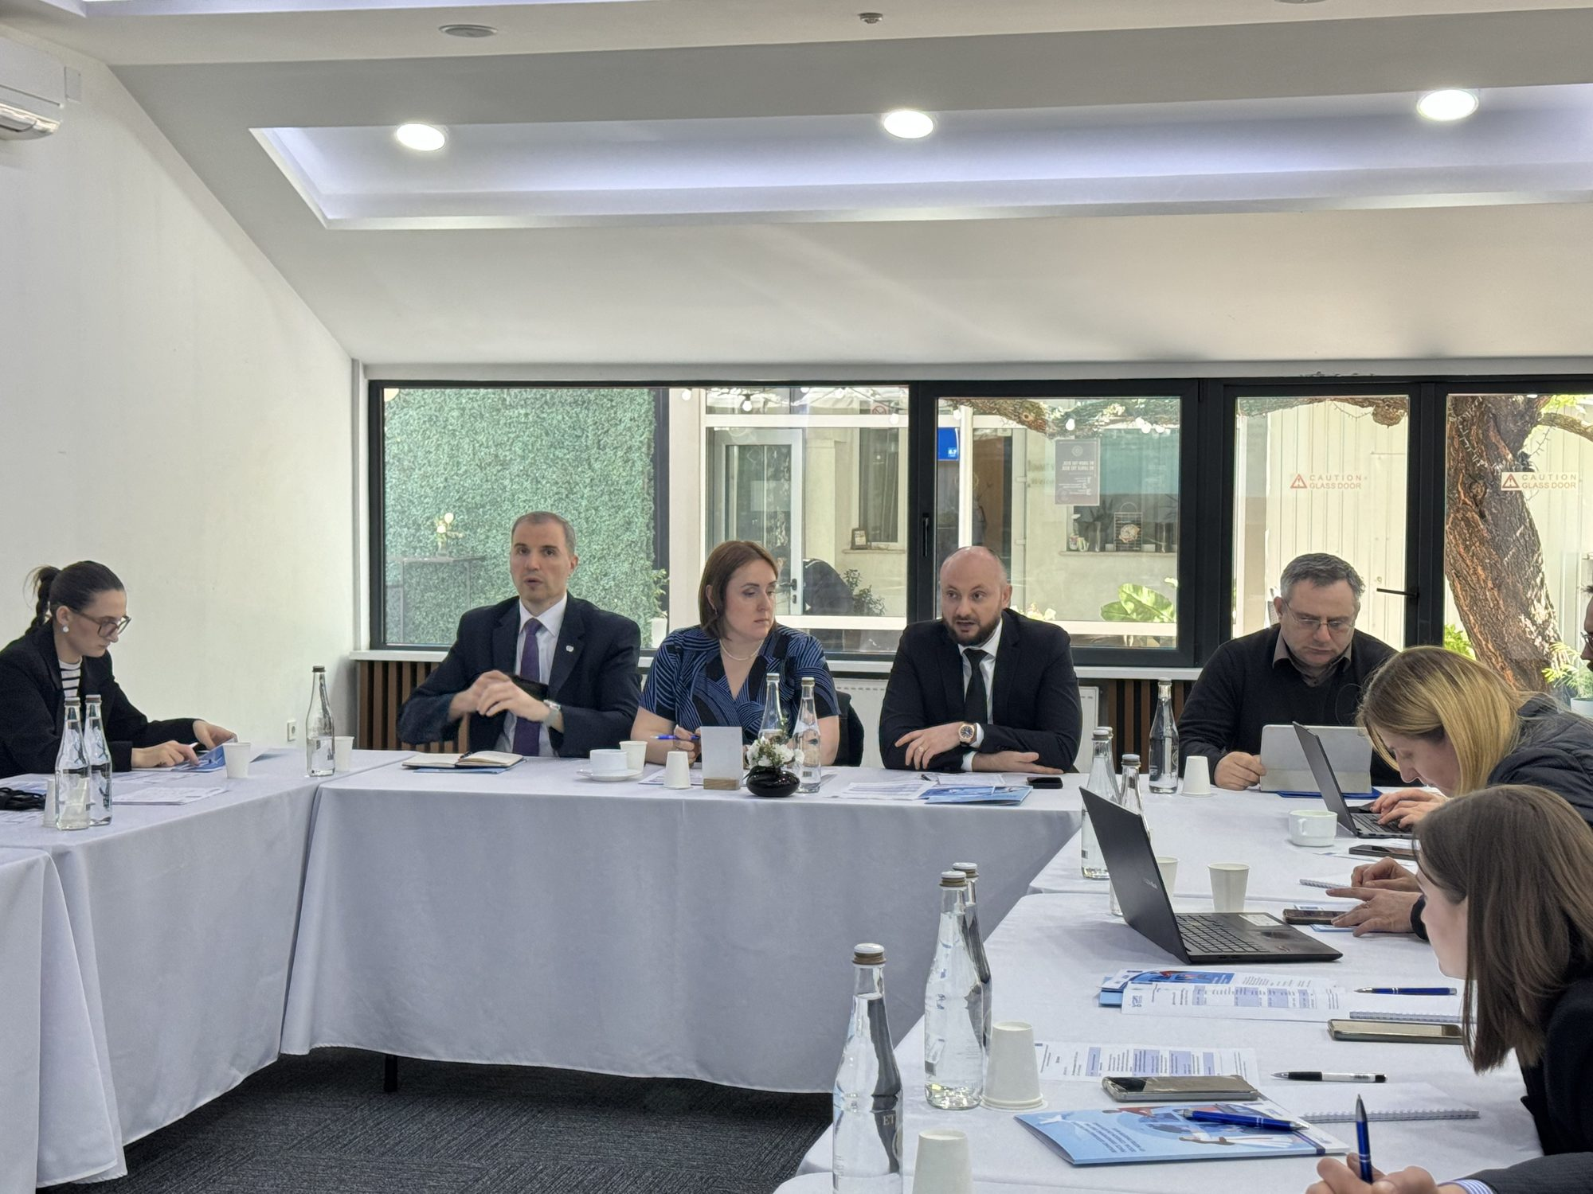

1.5. Conducting training courses in the field of legal aid for 3 representative NGOs from the Transnistrian region
A multi-modular training course was carried out in which 25 people, including people with disabilities, were trained as paralegals who will work in the Transnistrian region of the Republic of Moldova.
https://www.facebook.com/cdpdmd/posts/pfbid0YKJ12Cj1MWdYzeBJXgATVohUuePPSsAfStczjc85B3YcRA5tiziUZwC9wcdFda2El

1.6. Conducting visits on the exchange of experience and good practices between NGOs operating on both banks of the Dniester River in the field of defending the rights of persons with disabilities
5 visits on the exchange of experience and good practices between NGOs operating on both banks of the Dniester River in the field of defending the rights of persons with disabilities
https://www.facebook.com/cdpdmd/posts/pfbid02tbGV2YT8SnxVhzGkAH9L8N6soigGM3crUD1YGTRpYb8KmgPGfgisScJNA5UDSZpel
1.7. Elaboration of the handbook / manual of legal assistance in Russian for the activity of paralegals in the Transnistrian region
The handbook/ Paralegal's Guide for facilitating the activity of paralegals providing primary legal assistance services in the Transnistrian region of the Republic of Moldova has been developed. https://shorturl.at/1BOSz
Starting with 14.10.24, in the Transnistrian region of the Republic of Moldova, in partnership with 5 NGOs working in the field of disability: NGO "Sociohab", AO "VIALEX", AO "GLIN", AO "Алые паруса", AO "От рaвного к равному", the primary legal assistance service provided by the 25 paralegals trained by the CRPD was piloted, thus, about 900 beneficiaries belonging to underrepresented groups, including refugees from Ukraine living in the Transnistrian region, benefited from primary legal assistance services.
https://www.facebook.com/cdpdmd/posts/pfbid02RrV3CfDRbeQJMiwFMJeYVfzGY3eLuUB66Ph92WjnHk5fRzkUQx7bx3axdiL3mwCNl

https://www.facebook.com/cdpdmd/posts/pfbid032rGE1SieH51iceKFKhopjEUuvsh2vHT7G88iCGrqy8nSVxXbyCLZ3LnWFveNRW8cl
5 NGOs from the Transnistrian Region that work in the field of protection of persons with disabilities benefited from coaching from the CRPD regarding the primary legal assistance service, including being equipped with office furniture and equipment.

1.8 Evaluation of the building of the Ministry of Justice from the perspective of ensuring the conditions of physical and informational accessibility for litigants with disabilities

The accessibility assessment of the Ministry of Justice building was carried out by the Centre for the Rights of Persons with Disabilities (CDPD), at the request of the UNDP Moldova project "Strengthening the capacities of the Ministry of Justice of the Republic of Moldova to achieve the objective of justice reform".
To this end, the following actions have been carried out:
18.01.2024: Initial meeting, held jointly with the CRPD, UNDP and the Ministry of Justice
24.01.2024: Evaluation visit, carried out by the CDPD team and the representative of the General Directorate for Buildings Administration of the Government of the Republic of Moldova
13.02.2024: "User Safari" assessment of accessibility by people with visual, hearing and mobility disabilities. The "User Safari" activity involved people with disabilities, CRPD employees and partner organizations, UNDP and the Ministry of Justice. The activity consisted of:
- Movement inside the building of the Ministry of Justice. Evaluation of the entrance to the building
- Communicating with the guard at the reception, requesting information about the location of the citizens' hearing room.
- Evaluation of the citizens' hearing room, the functions of this room and the way in which they take into account its needs for access for people with disabilities.
- Evaluation of the sanitary group. Communication of the teams of evaluators with the guard, request information about the location of the sanitary group and navigation landmarks.
- Visiting the meeting rooms on the 1st and 2nd floors.
The recommendations presented in the report have been developed in accordance with the legislation, technical regulations and national standards in force:
For more details on the content of the evaluation report, please visit the following link: https://cdpd.md/raport-privind-realizarea-auditului-accesibilitatii-cladirea-ministerului-justitiei/

COMPONENT 2: STRATEGIC LITIGATION
In 2024, the CRPD initiated and administered 11 strategic litigation cases, in the following areas:
Right to housing and property, social protection, inclusive education, physical and informational accessibility, social service/personal assistance service, non-discrimination.

II: . ADVOCACY FOR PUBLIC POLICIES SENSITIVE TO THE NEEDS OF PERSONS WITH DISABILITIES
Ion Cibotărică, program director
Partners/Funders: IM SDP, UNDP, UNICEF, UNCHR, EDF, CBM, ERA/NDI, EEF
The activities were carried out in accordance with the CRPD Operational Plan for 2024, the following priority directions of activity were foreseen.

COMPONENT 3: EMPOWERING THE NATIONAL COUNCIL ON DETERMINING DISABILITY AND WORK CAPACITY
In 2024, CRPD within the UN PRPD program whose partners are 3 UN agencies, UNDP Moldova, UNICEF and OHCHR, CRPD as a partner organization aimed to contribute to the paradigm shift from the medical approach to the human rights-based approach in determining disability in children and determining disability and work capacity in adults. Thus, the following actions were undertaken:
- Assessment of the training needs and the lifelong learning environment of the CNDDCM with its territorial structures from the perspective of the human rights-based approach to the determination of disability in children https://rb.gy/t265ob
- Assessment of the training needs of CNDDCM employees from the perspective of the human rights-based approach in the process of determining the disability and work capacity of adults https://cdpd.md/raport-evaluarea-necesitatilor-de-instruire-a-angajatilor-cnddcm/
- Elaboration of the training guide for CNDDCM collaborators on the human rights-based approach in the process of determining disability in children https://cdpd.md/abordarea-bazata-pe-drepturile-omului-in-procesul-de-determinare-a-dizabilitatii-la-copii/
- Elaboration of the training guide for CNDDCM collaborators on the human rights-based approach in the process of determining disability and work capacity in adults https://cdpd.md/abordarea-bazata-pe-drepturile-omului-in-procesul-de-determinare-a-dizabilitatii-la-adulti/
- Elaboration of the training curriculum for CNDDCM collaborators
The following actions were also carried out:
- Training of trainers (TOT) on: Human rights-based approach in the process of determining disability in children and disability and work capacity in adults, among CNDDCM collaborators. Thus , 76 specialists of CNDDCM, from 38 districts of the country, including the municipality of Chisinau, benefited from the training program in 3 modules, on the human rights-based approach in determining disability in children and adults, in accordance with the International Classification of Functioning (ICF).
- The training courses were led by trainers from among the CNDDCM experts, beneficiaries of a previous training of trainers program carried out by the CRPD. They explained in detail how the procedure for determining the degree of disability according to the human rights-based approach should work efficiently. The basis of the evaluation process should be the identification of people's abilities and ways to compensate for their deficiencies, for their inclusion in society. https://cdpd.md/determinarea-dizabilitatii-la-copii-si-adulti-in-republica-moldova-se-va-face-conform-abordarii-bazate-pe-drepturile-omului/

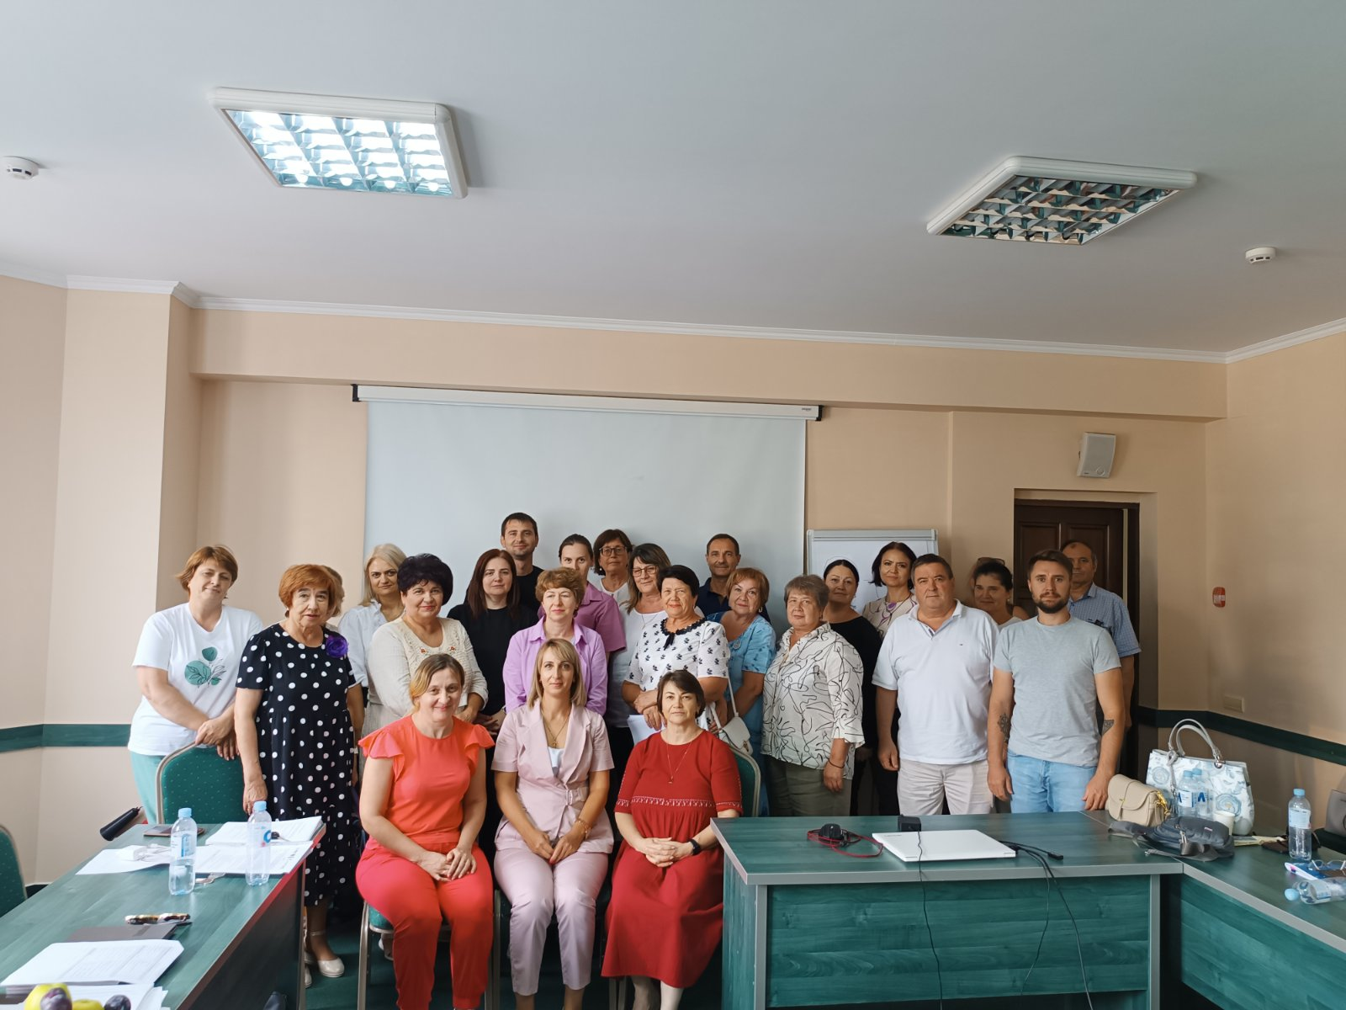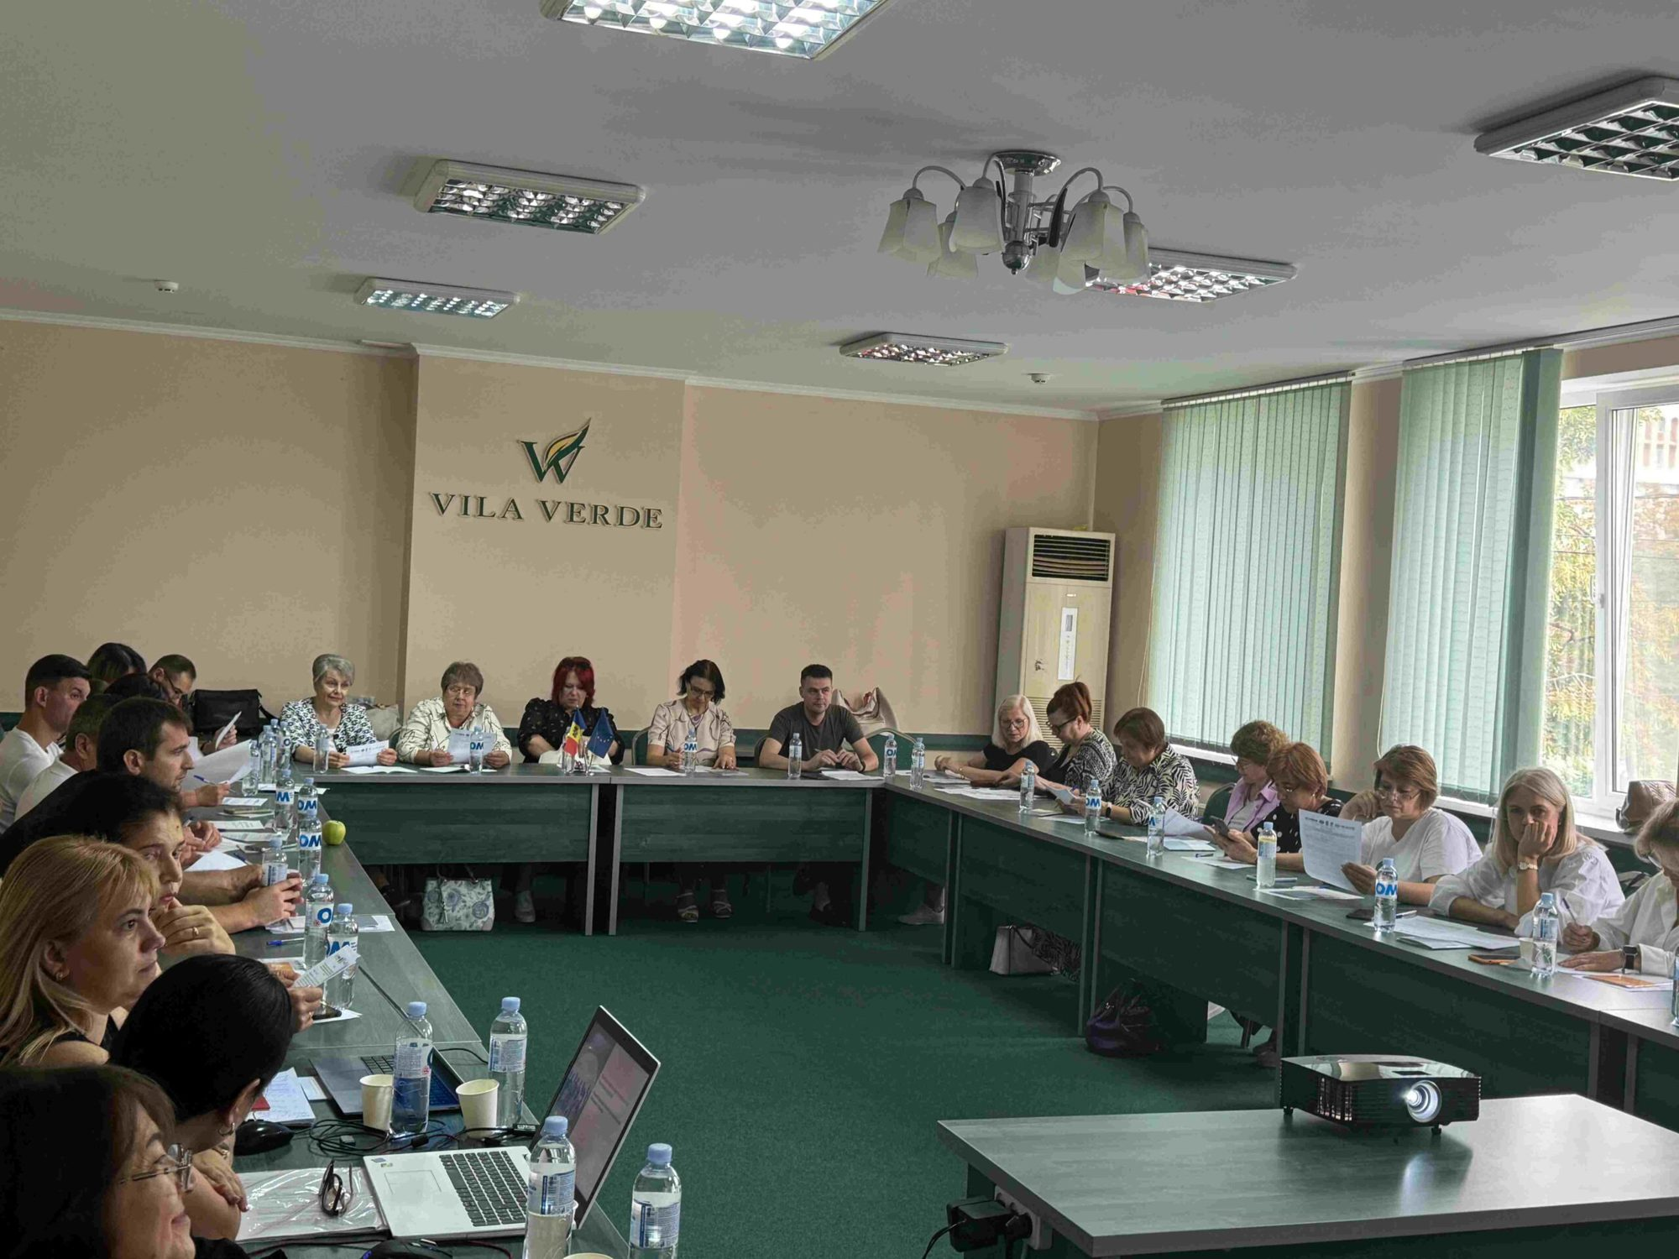

COMPONENT 4: THE PROCESS OF CONTINUOUS MONITORING OF THE RESPECT FOR THE RIGHTS OF PERSONS WITH DISABILITIES IS IMPROVED BY THE AUTHORITIES BASED ON THE ADVOCACY EFFORT CARRIED OUT BY THE CDPD
4.1. Presentation of information for the hearing session of the report 2 on the CRPD
On August 26-27, 2024, CRPD representatives participated in the working session of the UN Committee on the Rights of Persons with Disabilities to hear the report of the Government of Ukraine on the implementation of the UN Convention on the Rights of Persons with Disabilities. During the preliminary working sessions, the members of the UN Committee on the Rights of Persons with Disabilities had separate meetings with representatives of civil society in Ukraine and representatives of the Centre for the Rights of Persons with Disabilities.
The CRPD team presented to the members of the UN Committee the most problematic topics affecting persons with disabilities from Ukraine, refugees on the territory of the Republic of Moldova as a result of the war unleashed by Russia:
- People with disabilities and the elderly face barriers in accessing consular services at the consular representations of Ukraine in Moldova. Thus, the appointment for consular services is done electronically, requiring registration on the national electronic portal of Ukraine DIA. Many people do not have access to this portal and cannot, due to age or disability, register for consular services. Also, consular fees are very high and worsen the economic condition of low-income people.
- At the moment there are problems in terms of the provision of pensions and social allowances for Ukrainian refugees in the Republic of Moldova. These people cannot travel to Ukraine due to their health condition, either because of their physical condition or because of fear of war.
In his presentation, the CRPD rapporteur also offered recommendations for the recovery of the situation of people from vulnerable groups in Ukraine, who are temporarily on the territory of our country:
- Simplification of the procedure of access for Ukrainian citizens with disabilities to consular services at the diplomatic representations of Ukraine in Moldova. It is also recommended to apply facilities for the payment of consular services for refugees with a degree of disability, including established by the responsible authorities of Moldova.
- Concluding an Agreement between Moldova and Ukraine, which would regulate the mutual access to the social assistance system for the citizens of both countries, during the period of being on the territory of the countries, due to war situations.
As a result of the advocacy actions carried out by the CRPD at international level, the consular services offered by the diplomatic missions of Ukraine have become friendlier for persons with disabilities and thus the cost of consular services for the issuance of the travel passport of the citizen of Ukraine person with disabilities has been reduced from 130 USD to 40 USD.
People with disabilities, the elderly, the illiterate as well as other people who are part of the category of underrepresented people every Friday can benefit from consular services without an online appointment in advance.
Persons with disabilities as well as elderly persons with extremely reduced mobility can benefit at home from the consular services offered by the diplomatic mission through the mobile team. https://cdpd.md/reprezentantii-cdpd-au-participat-la-sedinta-comitetului-onu-pentru-drepturile-persoanelor-cu-dizabilitati-de-la-geneva/

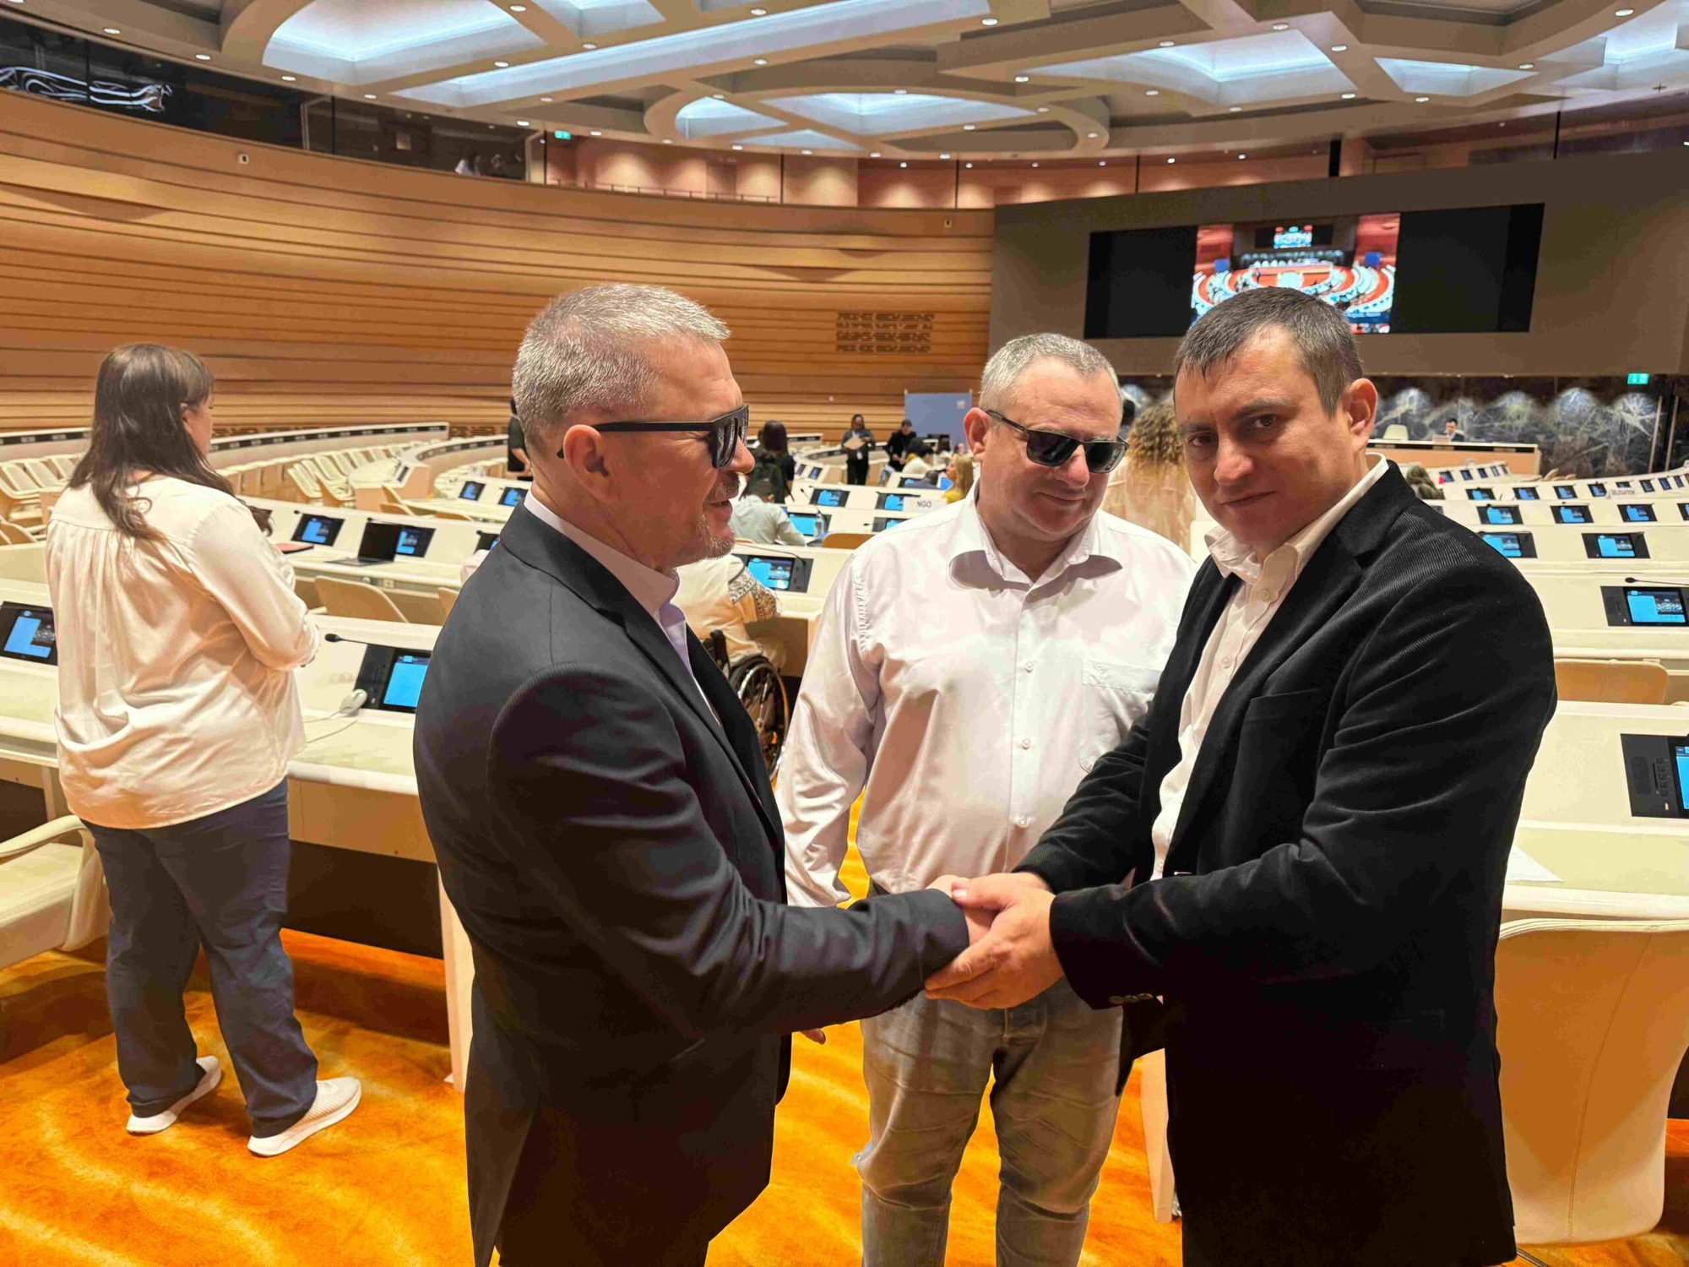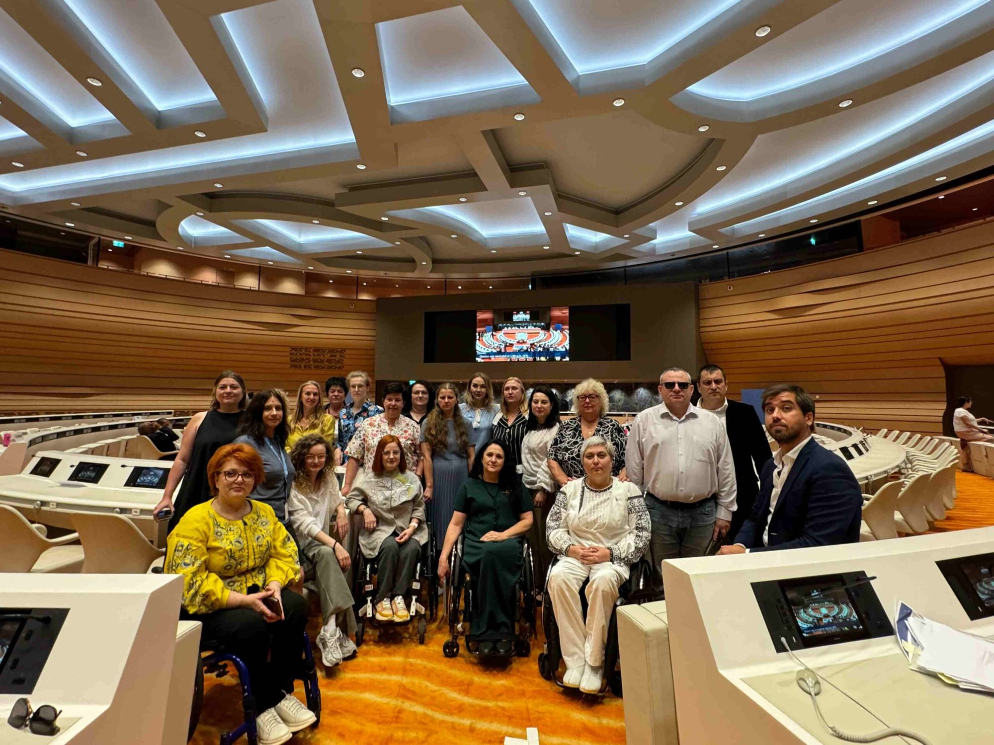

4.2. Submission of proposals for the List of Questions to the CRPD Committee
During 2024, CRPD, in partnership with the member organizations of the Alliance of Organizations of Persons with Disabilities (AOPD) and other partners, prepared an alternative report on the implementation of the UN Convention on the Rights of Persons with Disabilities in Moldova for the periodic review process of Moldova regarding the implementation of the UN Convention on the Rights of Persons with Disabilities.
On October 24, NGOs of persons with disabilities and organizations that provide support services met to review the most serious violations of the rights of persons with disabilities that occur in our country. The event was organized by the Centre for the Rights of Persons with Disabilities (CRPD) in cooperation with the Alliance of Organizations of Persons with Disabilities (AOPD) and partner associations.
During the consultation workshop, the representatives of the organizations offered their opinions from the perspective of the areas of expertise they have, therefore the chapters included in the report were completed and updated. Among the major issues reflected in the document, developed by persons with disabilities and civil society organizations, are: ensuring the right to education, employment, collection of disaggregated statistical data, accessibility of public buildings, passenger transport, information of general interest, etc.

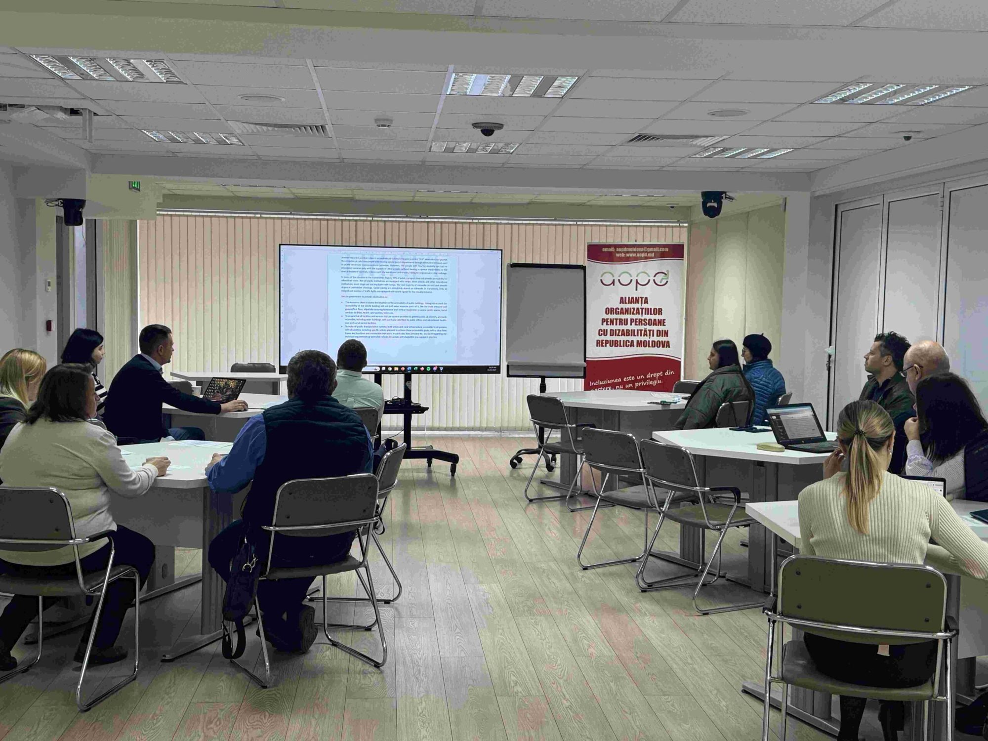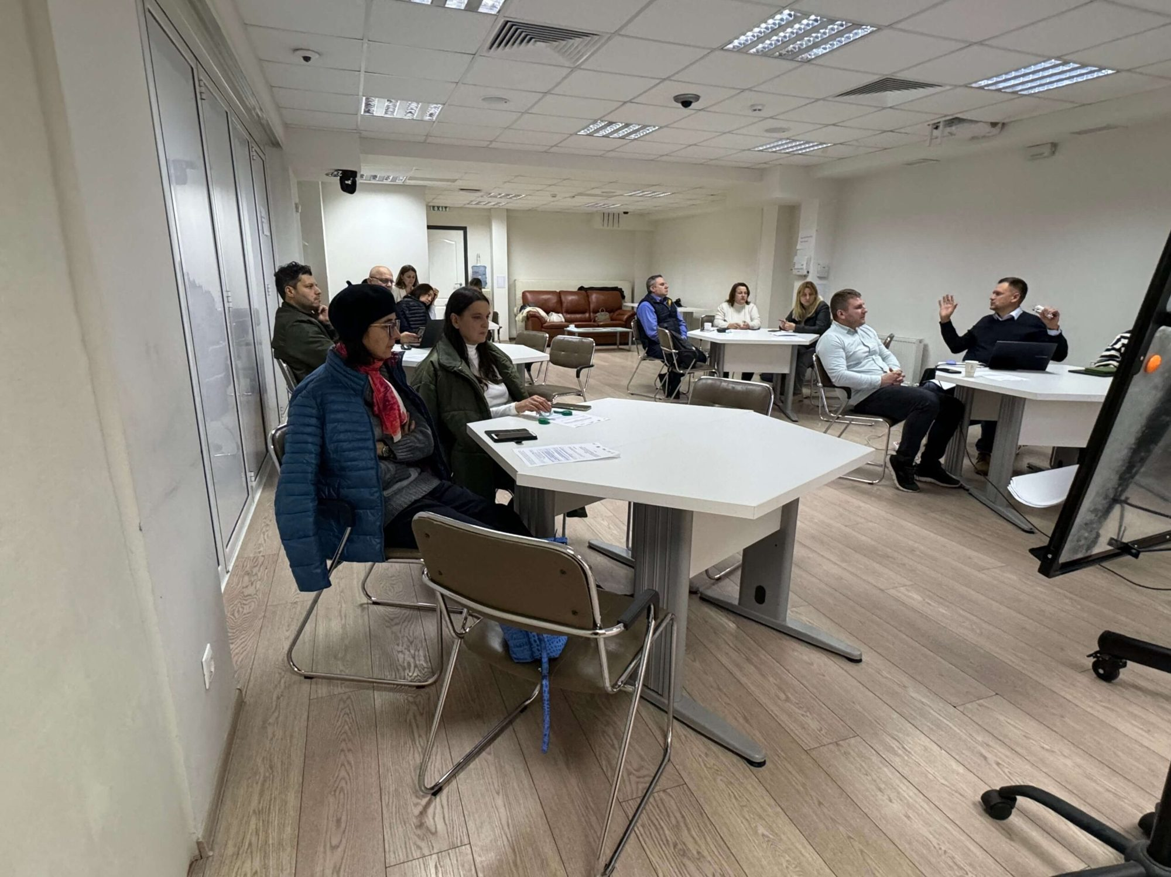

Subsequently, the participants prepared a list of questions that will be addressed to the representatives of the Government of the Republic of Moldova, in the process of hearings at the UN Committee on the Rights of Persons with Disabilities, which will take place on March 24-28, 2025, in Geneva. It is planned that a delegation made up of persons with disabilities and representatives of civil society organizations in Moldova will participate in the hearing of the report of the Government of Moldova.

The alternative report is an instrument provided for in the framework of the UN conventions, which offers non-governmental organizations in the member states the possibility to prepare a parallel report, alternative to the report submitted by the governments of their countries. By submitting alternative reports to the UN sectoral committees, civil society organizations highlight certain problems that are not reflected in government reports and, at the same time, increase the degree of transparency and objectivity of the information presented to the UN institutions. To find out more details on the content of the alternative report, please visit the link: https://tbinternet.ohchr.org/_layouts/15/treatybodyexternal/Download.aspx?symbolno=INT%2FCRPD%2FICO%2FMDA%2F62568&Lang=en
https://cdpd.md/persoanele-cu-dizabilitati-si-organizatiile-acestora-pregatesc-un-raport-alternativ-referitor-la-implementarea-conventiei-onu-privind-drepturile-persoanelor-cu-dizabilitati-in-moldova/

4.3. The potential of Moldovan universities in the implementation of the Inclusive Education Development Programme 2024-2027
The potential of Moldovan universities in implementing the Inclusive Education Development Program 2024-2027 was discussed at a round table organized by the Centre for the Rights of Persons with Disabilities in collaboration with the State University of Moldova (USM).
As part of the "Civil Society for European Integration" project, funded by the European Union and co-financed by the "Friedrich Ebert" Foundation, the Centre for the Rights of Persons with Disabilities organized a round table dedicated to the theme "The potential of Moldovan universities to implement the Inclusive Education Development Program 2024-2027" within the MSU, on November 14, 2024. The event took place in the "Queen Maria" Hall of the State University of Moldova and brought together representatives of several universities, officials from the Ministry of Education and Research, as well as experts in the field of inclusive education. Among the participants at the meeting was Mr. James Thomas Jackson, an expert in inclusive education from Howard University, in Washington.
One of the central topics of the round table was the presentation of the Ministry of Education and Research's vision on the implementation of the inclusive education development program for the period 2024-2027. The ministry's representatives detailed the proposed measures to ensure accessibility in higher education for young people with disabilities, especially in terms of adapting universities to international accessibility standards and providing assistive equipment and technologies for students with special needs.
Emma Matreniuc, director of the "Vivere" Association, as a person with locomotor disabilities and a graduate of the University of Moldova, presented from the perspective of a beneficiary how university educational services should be adapted so as to meet the needs of students with special needs. At the same time, Mr. James Thomas Jackson presented the best practices of inclusive education in universities in the USA.
During the round table, the CDPD expert, Ion Cibotărică, presented the Report on monitoring budget expenditures for inclusive education services in higher education institutions in Moldova. The document analyses the accessibility of the infrastructure and the educational process of universities for students with disabilities. In the same way, the report documents, quantitatively and qualitatively, the compliance of the measures carried out in terms of accessibility standards and proposes several recommendations to the institutions targeted in the study.
We remind that one of the objectives of the Ministry of Education and Research for the Inclusive Education Development Program 2024-2027 is that by 2027 the rate of young people with disabilities accessing higher education should reach 2% of the total number of students. According to official statistics of the Ministry of Education in the 2021-2022 academic year, the rate of students with disabilities in Moldovan universities was only 0.3%, which underlines the need for additional measures to encourage their integration into higher education.
The event was an important step in promoting a constructive dialogue between authorities, higher education institutions and organizations in the field of disability rights. In this context, the importance of collaboration between all parties involved to ensure adequate conditions for young people with disabilities was highlighted, thus promoting their access to quality education.
The full report can be accessed: https://www.euromonitor.md/raport-de-monitorizare-bugetara-monitorizarea-cheltuielilor-bugetare-pentru-serviciile-de-educatie-incluziva-in-institutiile-de-invatamant-superior-din-republica-moldova/

4.4. Monitoring of expenditures from the budget of Chisinau municipality. Chisinau 2023 for the renovation and accessibility works of underpasses
During 2024, the CDPD prepared the budget monitoring report. "Monitoring of expenditures from the budget of Chișinău 2023 for the renovation and accessibility works of underpasses"
Annually in Chișinău, millions of lei are spent on the construction and maintenance of roads and sidewalks, money from the municipal budget, as well as from loans and grants from development partners. The budget of the municipality of Chisinau for 2023 was approved with an amount of 6,812.374 million in revenues and 7,359.24 million in expenses. Of which, the expenses for the accessibility of the infrastructure are distributed on various budget lines, making it difficult to monitor the efficiency of their use.
From the analysis of the structure of the municipal budget presented in the report, we can see that the division of costs is not clear, the expenses for accessibility being in the same budget line as the renovation works, modernization of infrastructure objects. Also, the budget does not include specific monitoring indicators in the field of infrastructure accessibility. Thus, it will be difficult to monitor how much was spent on accessibility and how much on "modernization/renovation". For more details on the content of the report, please visit. https://cdpd.md/raport-de-monitorizare-a-cheltuielilor-din-bugetul-mun-chisinau-2023-pentru-lucrarile-de-renovare-si-accesibilizare-a-trecerilor-subterane/

4.5. Assessment of the accessibility of educational programmes and assistive means in technical vocational education institutions
During 2024, the CRPD conducted the Study Evaluation of the accessibility of educational programs and assistive means in technical vocational education institutions.
According to official data, in the 2022-2023 academic year, there were 90 technical vocational education (VET) institutions, of which: 41 vocational schools, 36 colleges and 13 centres of excellence. In these institutions, 32,143 students were studying. In total, 5,060 teachers work in the VET system. Of these, about 350 people benefited from training on the implementation of inclusive education. According to the Education Management Information System (SIME), 671 students with SEN and/or disabilities were studying in VET in the 2021-2022 school year.
In the absence of the development and empowerment of a system of inclusion of children with disabilities in VET, their access remains low and sporadic, and ensuring their right to education is restricted. Over 50% of graduates with SEN and/or disabilities of general secondary education, cycle I, do not continue their studies at the next educational stage.
Education is a fundamental right of all people, including those with disabilities, and plays an essential role in the development of a prosperous society. Education offers opportunities for personal and professional development, being an important factor in improving the quality of life and creating a fairer and more competitive social environment. The role of the education system is to prepare young people to become responsible and competent citizens, capable of harnessing their potential and contributing to the development of the local community. Education also plays a crucial role in the fight against poverty, discrimination and social exclusion. Through education, people are able to overcome the difficulties created by the socio-economic context and access opportunities for personal growth and development.
In the Republic of Moldova, steps have been taken towards inclusive education, but challenges persist, especially in vocational schools. These institutions play a crucial role in equipping people with practical skills for the workforce. However, ensuring equal access and support for students with disabilities remains a significant concern. In this study conducted by the CDPD, the problems faced by people with disabilities in vocational schools in the Republic of Moldova were identified and recommendations for improvement were proposed.
The study examines the researched problem in particular from the perspective of the challenges of inclusion of students with disabilities in VET and the problems of access to professional training courses offered by ANOFM. For more details on the content of the study, please visit: https://cdpd.md/evaluarea-accesibilitatii-programelor-educationale-si-mijloacelor-asistive-in-institutiile-de-invatamant-profesional-tehnic/

III: THE CDPD'S RESPONSE TO THE HUMANITARIAN CRISIS CAUSED BY THE WAR IN UKRAINE.
Adela Goncear , program director
Partners/Financiers: IM SDP, NRC, IOM, EDF, CBM.

The CRPD together with other civil society organizations in 2024 came up with a response to the humanitarian crisis as a result of the war unleashed by the Russian Federation in Ukraine, especially in terms of providing support to refugees, persons with disabilities and their family members. The CRPD's response to the humanitarian crisis referred in particular to:
- Evaluation of temporary accommodation centres for refugees in Ukraine from the perspective of ensuring accessibility conditions, including the services provided to refugees within them.
- Legal advice
- ICLA information, consultation and legal assistance
- Case management
- Individual material aid offered based on the assessment of the individual needs of the beneficiaries.
- Support for the reasonable accommodation of temporary placement centres, including private home owners who practice accommodation for refugees with disabilities.
- Offering food packages specific to individual and hygienic nutrition.
- Covering the costs of accessing consular services in order for diplomatic missions to issue travel passports for persons with disabilities, elderly persons and other disadvantaged persons, Ukrainian citizens.

Evaluation of Temporary Accommodation Centers for Refugees in Ukraine
During 2024, 15 temporary placement centres were evaluated.
Reasonable accommodation of 3 private dwellings in which disabled refugees from Ukraine are accommodated.
The support provided was for the accessibility of the WC and bathroom rooms, as well as sleeping rooms, by offering multifunctional beds that can be adapted to the individual needs of people with disabilities and electric radiators for heating the rooms during the cold period of the year.
Case management
The house management service was developed for people with disabilities refugees from Ukraine.
Thus, during 2024, the case management service processed and provided assistance for 400 requests from refugees, people with disabilities from Ukraine, of which 265 women and 135 men
Individual material aid for refugees with disabilities from Ukraine (IPA)
The CRPD, during 2024, managed to provide individual material aid to 900 refugees, persons with disabilities, of which 550 men, 350 women. The individual material aid provided by the CRPD consisted of:
- Providing food including special food products (gluten and lactose free).
- Personal hygiene products including adult diapers.
- Orthopaedic shoes.
- Medicines
- Covering the costs of medical investigations and surgeries
- Provision of medical equipment for health monitoring. (Electronic voice tonometers and glucose meters)
- Mobile chairs with toilet for adults, crutches, canes including for the blind as well as walking frame.
- Covering expenses for the processing of passports and consular services
Information, Consultation and Legal Assistance (ICLA)
The CRPD lawyers provided information, consultation and legal assistance services for 1382 refugees with disabilities including:
914 people who benefited from information and consultation services
468 people who benefited from Legal Assistance
Information, consultation and legal assistance services were provided in the following areas:
Social protection 230 cases
Healthcare. 329 cases
Medical equipment 79 cases
Temporary protection 375 cases
Inclusive education 26 cases
Employment 51 cases
Legal acts 292 cases

60 people with disabilities and elderly people benefited from financial support in the amount of 1850 lei per person in order to cover the costs for consular services in connection with the preparation of the travel passport.
CDPD-080008800 hotline
In order to ensure the access of refugees, persons with disabilities to the services and help offered by the CRPD to refugees, including other organizations that have come up with a response to the humanitarian crisis, the CRPD during 2024 maintained and made available to the beneficiaries the 080008800 hotline through which 2 case managers employed by the CRPD offered assistance to refugees from Monday to Friday between 9.00 and 18.00

Study on Evaluation of the Existing Regulatory Framework on Access to Health Services for Displaced Persons with Disabilities in Ukraine
In February 2024, the CRPD finalized and presented to public authorities and development partners the Study on "Assessment of the Existing Regulatory Framework on Access to Health Services for Displaced Persons with Disabilities in Ukraine" https://cdpd.md/studiu-evaluarea-cadrului-de-reglementare-existent-privind-accesul-la-serviciile-medicale-pentru-persoanele-cu-dizabilitati-stramutate-din-ucraina/
This research aimed to identify the existing gaps in the normative framework of the Republic of Moldova in the field of ensuring the access of displaced persons from Ukraine to healthcare services, in relation to the international standards on access of refugees (in particular, with disabilities) and to the models of good practices applied in neighbouring countries. The conclusions and recommendations developed within the study can be used as benchmarks for identifying solutions to improve the access of displaced persons from Ukraine, especially those with disabilities, to healthcare services, by amending and supplementing the existing regulatory framework.
Promoting the rights of persons with disabilities refugees from Ukraine

In order to promote the right to social protection of persons with disabilities refugees from Ukraine, the CRPD, in partnership with the Youth Media Centre, has developed and publicized in the online space 2 articles on the history of 3 beneficiaries who fight to claim their violated rights, namely ensuring the right to a pension in connection with the determination of disability and work capacity by the CNDDCM, as well as ensuring the right to financial, humanitarian aid and the right to housing.
To learn about the history of these 3 ladies who, with the legal support provided by the CDPD, campaigned for her rights, access the following links:
https://cdpd.md/lupta-unei-refugiate-pentru-drepturile-sale/ https://cdpd.md/refugiatii-ucraineni-departe-de-casa-lupta-pentru-a-si-construi-o-viata-noua/

  - ORGANIZATIONAL DEVELOPMENT
Partners/Funders: IM SDP, EDF, ERA/NDI, UNICEF, NRC
Development and review of the internal policies of the CRPD
Development of the CDPD Strategic Plan for 2025-2029
Development of the CRPD's Anti-Terrorism Policy
Review of the CDPD Procurement Manual
Visit, exchange of experience, Brussels EDF
Between December 17-19, 2024, the CDPD team carried out an experience exchange visit to the European Disability Forum ( EDF) in Brussels. The European Disability Forum consists of 114 national and network organizations. CDPD is a member of this forum. The purpose of this visit was to hold working meetings with representatives of the Advocacy and Public Policy, Accessibility, Intergroup Policies for Persons with Disabilities, Women's Rights, Communication, Climate, Human Rights and Non-Discrimination departments. A very important topic addressed is the implementation of the advocacy strategy related to collaboration with the Parliament, the European Council and the European Parliamentary Commission.
This experience exchange visit and collaboration with EDF will contribute to strengthening the efforts of the CDPD and partner organizations in the continuous involvement of civil society active in the field of social inclusion of persons with disabilities in order to implement the UN Convention on the Rights of Persons with Disabilities by government institutions in the Republic of Moldova.
https://www.facebook.com/cdpdmd/posts/pfbid02KjDxNchfTFNkWtbCDkMsF3v5rZZuFRmqpm2jb5GcjigFwhhPNyw5qj28tsryPQDVl

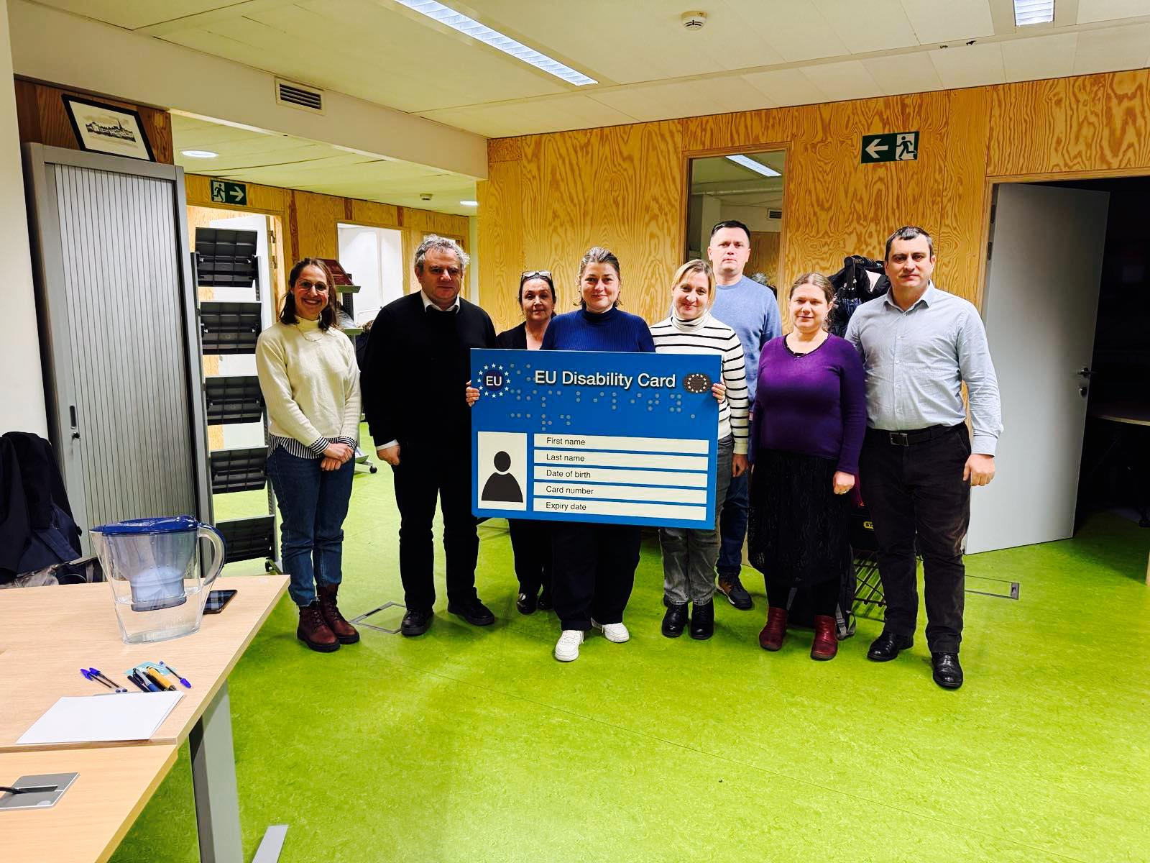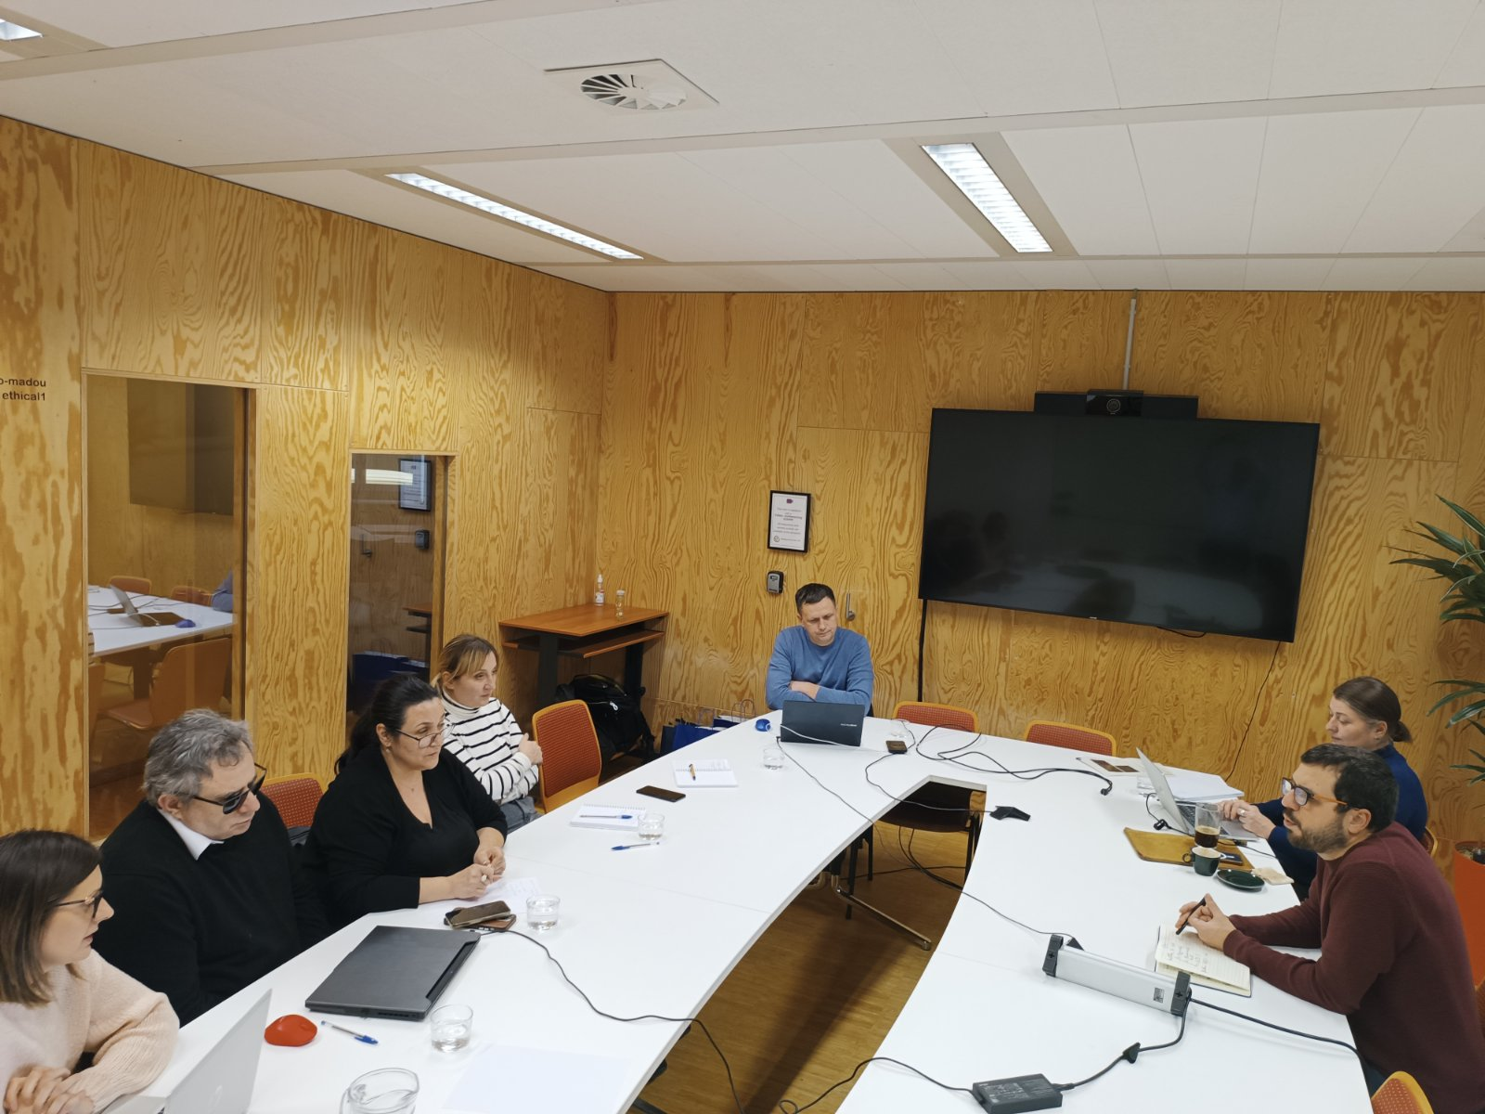

Conduct of the Independent Organizational Audit 2024
The Independent Organizational Audit CDPD 2024 can be viewed by accessing the following link. https://cdpd.md/independent-auditors-report-2024/
Implementing partners of the CDPD 2024 Operational Plan: European Disability Forum, AO Alliance of Organizations for Persons with Disabilities, AO INFONET Alliance, AO "Sociohab" AO "GLIN", AO "VIALEX", AO "Алые паруса, "АО "От равного к равному"

CRPD BUDGET 2024
The CDPD in 2024, the 6th consecutive year for budgeting the expenses established according to the Operational Plan, applied the consolidated budget. Thus, the consolidated budget of the CDPD for 2024 constituted: 11,749,286.42 MDL
Donor | Project name | Implementation Period | Approved Budget | Opening balance (MDL) | Income (MDL) | Spent until 31.12.2024 (MDL) | Current account balance
IM Swedish Development Partner(IM SDP) | Support for CRPD Strategic Plan | 01.04.24 - 31.12.24 | SEK 500 000 |  | 827,247.29 | 827,247.29 | 0
European Disability Forum (EDF) | Ukraine war: OPD led disability inclusive response and recovery (Phase 2) | 01.07.23 -31.12.24 | 150 000EUR | 7,444.92 | 1,926,072.10 | 1,933,517.02 | -
Equal Rights in Action Fund (ERA/NID) | To support local human rights NGOs in their efforts to achieve safe and secure environments, political participation, and еmроwеrеd and inclusive movements and organizations" | 01.01.23-31.05.25 | (2884+9326+ 10788) USD | - 54,581.04 | 411,189.24 | 356,608.20
Expert Group Centre for Independent Analysis AO | "Resilient CSOs + Responsible Budgeting=Accelerated Association Agreement implementation." | 01.06.23-31.12.24 | 11 886.92 EUR | 35,889.37 | 191,400.00 | 227,289.37
East Europe Foundation (FEE) | Together we develop inclusive employment services for people with disabilities in Chișinău and Criuleni | 18.02.22-31.03.24 | 2 864.89 EUR | 24,649.61 | 30,338.00 | 54,987.61
International Organization for Migration (IOM) | "Needs-based support for refugees with disabilities from Ukraine in Moldova" phase 1 | 01.02.23-28.02.25 | 278 337.56 MDL | 152,113.70 |  | 158,773.50 | - 6,659.80
International Organization for Migration (IOM) | "Needs-based support for refugees with disabilities from Ukraine in Moldova"phase 2 | 01.02.24-31.08.24 | 1,015,338 MDL |  | 1,015,338.00 | 1,015,338.00
International Organization for Migration (IOM) | "Needs-based support for refugees with disabilities from Ukraine in Moldova"phase 3 | 1.12.24-31.05.25 | 1,525,140 MDL |  | 660,000.00 | 146,293.83 | 513,706.17
Norwegian Refugee Council (NRC)1 | Strengthening access to legal assistance and information for Ukrainian refugees with disabilities and other vulnerable groups. | 01.02.23-14.11.23 | 2,141,410 MDL | - 214,141.00 | 214,141.00 |  | -
Norwegian Refugee Council (NRC)2 | Facilitating access to legal aid for displaced persons with disabilities in Ukraine and other vulnerable groups. | 01.03.24-30.11.24 | 2,340,791 MDL |  | 2,106,711.90 | 2,340,790.92 | - 234,079.02
United Nation Development Programme (UNDP) | Paradigm Shift to Disability Inclusive Services, Accountability and Governance in Moldova | 30.03.23-30.09.24 | 37,866.19 USD | 162,958.88 | 508,718.26 | 671,677.14 | -
United Nations Children’s Fund (UNICEF) | Capacity building of the NCDDWA on the human-rights based approach to disability determination, in alignment with the International Classification of Functioning (ICF), including for children and youth | 05.06.23-30.09.24 | 653,695.24 MDL | 285,988.39 | 366,463.00 | 652,451.39
United Nation Development Programme (UNDP) | Building sustainable and inclusive peace, strengthening trust and social cohesion in Moldova (Phase 1) | 30.11.23-30.07.24 | 1 370 929.25 MDL | 1,197,422.25 | 173,507.00 | 1,370,929.25
United Nation Development Programme (UNDP) | Building sustainable and inclusive peace, strengthening trust and social cohesion in Moldova (Phase 2) | 14.10.24-30.04.25 | 2,471,342 MDL |  | 2,471,342.00 | 1,913,042.76 | 558,299.24
Euro-Asia JUDY Foundation | Mentorship Program | 01.07.24-31.05.25 | 4,250 USD |  | 39,644.19 | 80,340.14 | - 40,695.95
World Health Organization (WHO) | Access to medical services for refugees | 01.01.23-31.03.24 | 24,820 USD | 179,556.52 | 265,336.54 |  | 444,893.06
Economic activity |  |  |  | 111,995.34 | 131,853.69 |  | 38,236.73
Subsidy |  |  |  |  | 45,000.00
TOTAL |  |  |  | 1,889,296.94 | 11,384,302.21 | 11,749,286.42 | 1,273,700.43

Chisinau Municipal Council Decision no. 23/2 of 27.12.2022
https://dataset.gov.md/resources/2023-06/Date%20statistice%20generale%2C%20Educa%C8%9Bie%2C%202022-2023.pdf
Programme for the development of inclusive education in the Republic of Moldova for 2024 – 2027
Ibid.

