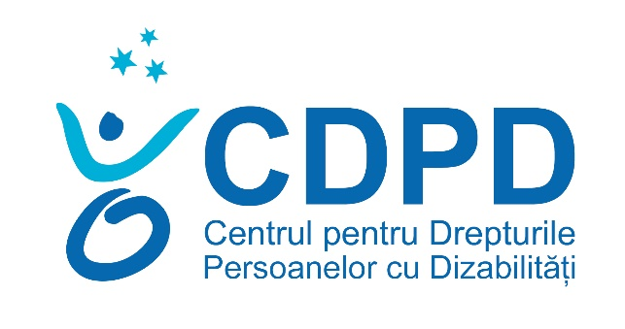
Centre for the Rights of Persons with Disabilities
ACTIVITY REPORT 2023

 Institutional partner IM SDP

The vision of the association is encapsulated in our commitment to contribute to the creation of an inclusive society in which all men and women, boys and girls with disabilities in the Republic of Moldova, without discrimination, enjoy respect for their human dignity.
Our mission is to promote and protect the rights of persons with disabilities, without distinction of race, colour, nationality, ethnic origin, language, religion or belief, gender, sex, age, opinion, political affiliation or any other similar criterion, to favour social inclusion and their spiritual fulfilment through monitoring actions, advocacy and programs to develop their potential.

Values
CRPD creates partnerships for an inclusive society for all, following the principle of respect for Human Dignity.
- Love for others: the most important call is to value and care for people;
- Integrity: consistency, honesty, fairness and transparency – assessed by the accuracy of our actions;
- Excellence: we are committed to the highest professional standards;
- Family: we value the balance between family, personal and professional development;
- Equal opportunities: we contribute to everyone's full participation in public life.
Strategic objectives
• Facilitating the gradual adjustment of national legislation and public policies to the provisions of the UN Convention on the Rights of Persons with Disabilities
• Defending the rights of persons with disabilities
• Economic empowerment of persons with disabilities
• Participation in political and public life of persons with disabilities.
Areas of expertise:
- Advocacy for the promotion of the rights of persons with disabilities.
- Strategic litigation for the defence of the rights of persons with disabilities.
- Monitoring compliance with the rights of persons with disabilities.
- Analysis of public policies in the field of the rights of persons with disabilities in the light of international standards in the field of human rights.
- Participation in political and public life of persons with disabilities.
- Physical and informational accessibility according to the concept of universal design.
- Protection against discrimination of persons with disabilities.

CRPD programs implemented in 2023
- RIGHTS OF PERSONS WITH DISABILITIES
- ADVOCACY FOR PUBLIC POLICIES SENSITIVE TO THE NEEDS OF PERSONS WITH DISABILITIES
- CDPD'S RESPONSE TO THE HUMANITARIAN CRISIS CAUSED BY THE WAR IN UKRAINE.
- SOCIAL ENTREPRENEURSHIP, ECONOMIC EMPOWERMENT AND SUPPORTED EMPLOYMENT
    - RIGHTS OF PERSONS WITH DISABILITIES
Elena Stajila , Program Director
The activities were carried out in accordance with the CRPD Operational Plan for 2023, the following priority directions of activity were foreseen.

COMPONENT 1: LEGAL AID
In 2023, the CRPD provided legal assistance to 379 people, of whom 251 were women and 128 men.
272 - beneficiaries of primary legal assistance;
107 - beneficiaries of qualified legal assistance;
Art. 182 – requests, petitions, complaints, notifications, requests to challenge court decisions, etc. drawn up in the name and in the interest of the beneficiaries, addressed to public authorities, as well as to other institutions, organizations.
47 - participation of the CRPD representatives in court hearings and the equality council for the purpose of defending persons with disabilities as well as in cases of public interest.
Legal assistance was also provided to 15 NGOs: Elșadai Association, Federation of Visually Impaired Athletes, Neemia Association. AOPD, ANM, FCPS, Dolna Association, ASRM, INFONET Alliance, Sunshine, SOS AUTISM, ACM, AO Motivation; CMT, Straseni Blind Association.

Public Lessons
There were 69 public lectures, information workshops, carried out in off/online format, during which 720 people were informed on various topics related to the field of people with disabilities.

COMPONENT 2: STRATEGIC LITIGATION
In 2023, the CRPD initiated and administered 8 strategic litigation cases,
Results achieved through strategic litigation processes:
- Cebotari Vera case
- The proposed goal: to amend the legislation so that it is possible to review court decisions on the grounds of declaring the nullity of the notarial acts used as evidence when issuing those decisions.
- The result achieved: the Chisinau Court of the Centre accepted the request of the CDPD beneficiary to notify the Constitutional Court. On December 21, 2023, the Constitutional Court issued a decision of inadmissibility on the complaint.
- The CRPD at the beginning of 2024 on the mentioned case in the interest of the beneficiary Cebotari Vera will file a complaint with the European Court of Human Rights ECtHR against the Government of the Republic of Moldova.

- The case "Deaf children vs. MEC for ensuring sign language learning in the educational process"
- The proposed goal: to claim the right of deaf children to learn sign language and to use it in the educational process
- Result achieved: Although the CRPD has been judging with the MEC for more than 2 years, the examination of the case was blocked for administrative reasons, namely: the panel of judges does not have a clerk. On February 5, 2024, the next hearing to examine the case is to be held. If the first instance does not accept the claimants' claims, the CDPD will prepare a complaint in the interest of the beneficiaries at the ECtHR.

- Case 'Recognition of the right to customs exemptions on the importation of means of transport for persons with different types of disability, without discrimination'
- The proposed goal: to eliminate the discriminatory provisions of Law no. 60 on the social inclusion of persons with disabilities, so that exemptions from the import of means of transport are granted to all persons eligible for the social service "Personal assistance", regardless of the type of disability (locomotor, visual, psychosocial, etc.)
- Result achieved: In February 2023, the CRPD notified the Equality Council in order to issue an Opinion, which would assess whether the provisions of Law no. 60 on the social inclusion of persons with disabilities generate discrimination against persons with disabilities other than locomotor disability in accessing customs and tax exemptions for the import of means of transport. Subsequently, amendments were made to Law 60/2012, which generated significant delays in issuing the Opinion. The CRPD is waiting for the Council's Opinion on the submitted request.

- Case "Caraman and Cogut vs. CNAS regarding the modification of the formula for recalculating the disability pension"
- The proposed goal: to eliminate the discriminatory provisions of Law no. 156/1998 on the public pension system, so that the same formula that is used for the recalculation of the old-age pension is applied to the recalculation of the disability pension
- The result achieved: the CDPD initiated 2 cases in court, both of which are currently pending before the Chisinau Court, Riscani headquarters. In these two cases, the CDPD raised the exception of unconstitutionality on the provisions of the Law on the Public Pension System, which provides for a less favourable formula for recalculating the disability pension compared to the formula provided for the recalculation of the old-age pension. The examination hearings for the two cases are scheduled for February 2024 (26.02.2024 – Caraman case) and October 2024 (28.10.2024 – Cogut v. CNAS case).

- The case "Bargan vs CNAS regarding the granting of the care, accompaniment and supervision allowance to persons with severe disabilities, without discrimination"
- The proposed goal: to eliminate the discriminatory provisions of the Law on State Social Allowances, so that the care, accompaniment and supervision allowance is granted to all persons eligible for the social service "Personal Assistance"
- The result achieved: the CRPD notified the Equality Council in order to issue an Opinion, which would assess whether the provisions of the Law on State Social Allowances generate discrimination against persons with severe disabilities in access to care, accompaniment and supervision allowance. The Equality Council recognized as discriminatory the provisions of the law that grants the right to care, accompaniment and supervision allowance only to persons whose severe disability appeared up to the age of 18. Subsequently, the CRPD initiated a strategic litigation case against CNAS. The CRPD prepared and submitted a request for summons in the interest of the beneficiary. We are currently waiting for the court to establish the first court hearing. In this case, the CRPD will raise the exception of unconstitutionality on the legal provisions, which the Equality Council has qualified as discriminatory.

- The case "Jubea vs CNAS regarding the granting of the allowance for the loss of the maintainer to children with disabilities, without discrimination"
- The proposed goal: to eliminate the discriminatory provisions of the Law on State Social Allowances, so that children with disabilities can benefit from the disability allowance and the allowance for the loss of the maintainer at the same time.
- The result achieved: the CRPD notified the Equality Council in order to issue an Opinion, which would assess whether the provisions of the Law on State Social Allowances generate discrimination against children with disabilities in accessing the allowance for the loss of the maintainer. The Equality Council recognized as discriminatory the provisions of the law that provide for the right to choose between the disability allowance and the allowance for the loss of the maintainer and do not recognize the possibility for the child with disabilities to benefit simultaneously from both types of allowances. Subsequently, the CDPD initiated a strategic litigation case against CNAS. The initial application and the preliminary application were submitted. A request for summons was drawn up and submitted in the interest of the beneficiary. We are currently waiting for the court to establish the first court hearing. In this case, the CRPD will raise the exception of unconstitutionality on the legal provisions, which the Equality Council has qualified as discriminatory.

- Case of Blanari Valeriu (malpractice)
- Proposed goal: To establish a judicial practice regarding the investigation of malpractice cases, in accordance with international standards, in particular those of the ECtHR jurisprudence on Articles 3 and 6 of the ECHR.
- The result achieved: In 2023, the expertise was carried out, the result of which showed that Mr. Blanari had a vision acuity in both eyes of only 0.01%, respectively, even if the intervention was unfounded, the expertise suggested that Mr. Blanari did not suffer any damage caused to his health. The expert report follows mentioned CRPD challenged it in the order established by law. Therefore, the said expert report was annulled and by the hierarchical superior prosecutor it was called a repeated expertise.

- Case of Sarandi Svitlana 9 citizen of Ukraine) vs CNAS
- Proposed goal: To ensure the right to social protection of persons with disabilities refugees from Ukraine without discrimination on an equal basis with persons with disabilities, citizens of the Republic of Moldova
- Actions taken: during 2023, the CRPD provided legal assistance to the beneficiary Sarandi Svetlana, a citizen of Ukraine, in the process of determining her disability and work capacity. Therefore, the CNDDCM caused the SS beneficiary to have a severe disability. In turn, following the beneficiary's application to the CNAS to establish the social allowance in connection with the establishment of disability, she was refused. This refusal is based on the legal provisions according to which only persons with disabilities who are citizens of the Republic of Moldova can benefit from social allowances for adults. On this case, the CDPD initiated a strategic litigation process, thus, a request for a summons was drawn up and submitted in the interest of the beneficiary. We are currently waiting for the court to set the first court hearing. In this case, the CDPD will raise the exception of unconstitutionality on the legal provisions, which restricts access to the right on social protection for persons with disabilities who are not citizens of the Republic of Moldova. (Annex 1. SS CNS Application, Annex 2. SS CNAS Refusal, Annex 3 Summons Request)

COMPONENT 3: EMPOWERING THE NATIONAL COUNCIL ON DETERMINING DISABILITY AND WORK CAPACITY
In 2023, CRPD within the UN PRPD program whose partners are 3 UN agencies, UNDP Moldova, UNICEF and OHCHR, CRPD as a partner organization aimed to contribute to changing the paradigm from the medical approach to the human rights-based approach in determining disability in children and also determining disability and work capacity in adults. Thus, the following actions were undertaken:
- Assessment of the training needs and lifelong learning environment of the CNDDCM with its territorial structures from the perspective of the human rights-based approach to the determination of disability in children (Annex 4. CNDDCM Children's Evaluation Report)
- Assessment of the training needs of CNDDCM employees from the perspective of the human rights-based approach in the process of determining disability and work capacity in adults (Annex 5. CNDDCM Adult Evaluation Report)
- Elaboration of the training guide for CNDDCM collaborators on the human rights-based approach in the process of determining disability in children (Annex 6. CNDDCM training guide for children)
- Elaboration of the training guide for CNDDCM collaborators on the human rights-based approach in the process of determining disability and work capacity in adults (Annex 7. CNDDCM training guide for adults)
- Elaboration of the training curriculum for CNDDCM collaborators (Annex 8. Children's curriculum, Annex 9. Adult curriculum)
Actions in 2024: During 2024, the CRPD aims within the UN PRPD partnership to carry out the following actions:
- to carry out 2 TOT training cycles in the field of human rights-based approach in the process of determining disability in children and adults, 6 CNDDCM collaborators who in turn will train the other 40 CNDDCM collaborators who are involved as experts/specialists in the process of determining disabilities and work capacity both at central level and in the territorial structures of CNDDCM.
- To pilot with the aim of paradigm shift in 3 regions (Balti-North, Chisinau-Centre, Cahul-South) the application of the human rights-based approach in the process of determining disability and work capacity.

COMPONENT 4: EMPOWERMENT OF PARALEGALS AND LAWYERS
At the end of 2023, the CRPD, in partnership with the National Council for State-Guaranteed Legal Assistance and the National Association of Paralegals of Moldova, initiated the process of creating the network of paralegals in the Transnistrian region. Thus, within this initiative, the CRPD selected 25 persons with disabilities from the Transnistrian region, who, during 2024, will benefit from the CRPD from a training program in the field of human rights, especially in relation to the rights of persons with disabilities, as well as will benefit from a coaching program in order to provide primary legal assistance services to persons with disabilities and other persons belonging to underrepresented groups living on the left bank of the Dniester.
The network of paralegals developed by CDPD on the left bank of the Dniester is to provide primary legal assistance in the following localities: Tiraspol, Slobozia, Tighina, Dubasari- Grigoriopol, Ribnita- Camenca.
In order to create the network of paralegals who will work on the left bank of the Dniester River, the CDPD has developed a roadmap. (Annex 10. Roadmap)
COMPONENT 5: EMPOWERMENT OF JUDGES
5.1.Assessment of the physical accessibility of courts
During 2023, CRPD, in partnership with the Infonet Alliance, evaluated the headquarters of 10 Courts, including the headquarters of the Ministry of Justice of the Republic of Moldova, from the perspective of ensuring physical and informational accessibility conditions.
Impact: As a result of the actions taken by the CRPD described above in this chapter, 3 courts of law (Palace of Justice in Ungheni, Headquarters of the Balti Court, Telenesti Headquarters of the Orhei Court), have improved their accessibility conditions. In turn, in 2024, with the support of UNDP Moldova, the Ministry of Justice has committed to creating/ensuring accessibility conditions for people with reduced mobility at the entrance to the Ministry building. access to the courtroom, including creating an accessible toilet.
5.2. Assessment of the accessibility of the web pages of courts and judicial authorities
As a result of the actions taken by the CRPD, in this chapter, in 2022, which consisted of assessing the web accessibility of 24 courts and judicial authorities.
This assessment of the web accessibility of court pages was based on WCAG 2.0 guidelines and specifically referred to: Contrast+ , Highlight URLs, Larger Text, Text Space, Stop Animations, Friendly Dyslexia/Readable Fonts, Cursor, Reading Mask, Reading Guide, Bubbles, Line Height, Text Alignment, Saturate, Reset All, Move/Hide Widget.

Impact: Therefore, the Courts Administration Agency AAIJ, based on the findings/recommendations of the CRPD described in the above-mentioned evaluation report, in 2023 undertook measures to improve the web accessibility of the portals of the Courts, including the website under the administration of the AAIJ.

II.ADVOCACY FOR PUBLIC POLICIES SENSITIVE TO THE NEEDS OF PERSONS WITH DISABILITIES
Ion Cibotărică, program director
The activities were carried out in accordance with the CRPD Operational Plan for 2023, the following priority directions of activity were foreseen.
COMPONENT 1: PUBLIC POLICY DOCUMENTS THAT SPECIFICALLY ADDRESS THE NEEDS OF PEOPLE WITH DISABILITIES
Activities carried out:
- CRPD's contribution to the elaboration of the National Program for the Social Inclusion of Persons with Disabilities 2024—2028
Between January and June 2023, CRPD representatives participated in the activity of the "Accessibility" Working Group attached to the Parliamentary Committee on Health and Social Protection. Within this working group, jointly with other partner CSOs, the following actions were carried out:
- Elaboration of the Questionnaire for the Evaluation of the Accessibility of the Public Building (Annex 11. Evaluation Questionnaire) The questionnaire was developed as a result of joint meetings with the CDPD, the Motivation Association, the Association of the Blind of Moldova, AOPD. The document was also consulted with the Ministry of Labour and Social Protection.
- Establish, in agreement with the members of the Accessibility Working Group, attached to the Parliamentary Committee, the list of priority actions that are necessary for changes in the area of infrastructure accessibility.
  - Inclusion of requirements for the accessibility of public buildings to the periodic attestation/accreditation procedures followed by educational and medical institutions
  - Approval of a set of minimum accessibility requirements for public institutions and an evaluation questionnaire
  - Launch of a government accesibilitate.gov.md portal that would allow the collection of data from public institutions that have been assessed
  - Approval of existing government programmes (European Village, etc.) and other new programmes to support building renovation projects to improve their accessibility.
  - Carrying out an evaluation of the existing regulatory framework and adjusting the control and sanctioning mechanism in order to comply with the regulations related to the accessibility of buildings, transport, services and public information.
- Granting the membership of the CDPD representative Ion Cibotărică of the group for the elaboration of the National Program on the Social Inclusion of Persons with Disabilities 2024-2028, being responsible for the "Objective 2. Accessibility" department. The text of the program has been argued and included the actions indicated above, as well as other actions, including:
- Strengthening the capacities of technical professionals in the application of universal design and accessibility standards through initial and continuing professional training programs
- Improving sign language interpretation insurance services for the hearing impaired (including online)
- Integration into the Single National Service for 112 Emergency Calls of the functionalities accessible for people with hearing disabilities
- Making official websites and electronic services available to the public accessible
The draft of the national program is attached to Annex 12. Draft program 2024-20228

RESULT: The National Inclusion Program for the Social Inclusion of Persons with Disabilities 2024—2028 was developed in a participatory manner and practically all the actions promoted by the CRPD and partners, in the field of accessibility,

COMPONENT 2: THE PROCESS OF CONTINUOUS MONOTORIZATION OF THE RESPECT FOR THE RIGHTS OF PERSONS WITH DISABILITIES IS IMPROVED BY THE AUTHORITIES BASED ON THE ADVOCACY EFFORTS CARRIED OUT BY THE CDPD

- Submission of proposals for the List of Questions to the CRPD Committee
CRPD facilitated the process of collecting the opinions of CSOs in the field and drafting the text of the Alternative-Consolidated Report of Organizations in the field for the UN Committee on the Rights of Persons with Disabilities. 11 NGOs from all over the republic, including from the Transnistrian Region, were involved in the drafting of the report: CDPD, AOPD, Alliance of Parents of Persons with Disabilities "Eternitate", Association of the Deaf of the Republic of Moldova, "Motivation" Association, INFONET Alliance, FCPS Criuleni, Keystone Moldova, etc.
The report contains 14 articles, which refer to the most frequent violations of the rights of persons with disabilities in the Republic of Moldova. (Annex 13 Alternative report)
The report was to be sent to the UN CRPD Committee for preparation for the session scheduled for September 2024.
Planned actions: In 2024 the CRPD plans to participate in the work of the One CRPD Committee on the Committee's assessment of the Republic of Moldova scheduled for September 2024.

COMPONENT 3: THE LEGAL AND REGULATORY FRAMEWORK INTEGRATES SEVERAL PROVISIONS ON ACCESSIBILITY TO INFRASTRUCTURE AND INFORMATION AS A RESULT OF LITIGATION PRACTICES
Activities carried out:

- Elaboration of the opinion on the draft amendment of the normative framework regarding the Urban Planning and Construction Code
The CDPD actively participated in the public discussion of the draft Urban Planning and Construction Code.
- February 10, 2023 Consultation meeting on the draft Urban Planning Code at AOPD
- April 28, 2023 meeting at the Ministry of Infrastructure and Regional Development (MIDR) on the draft Urban Planning Code
The Urban Planning and Construction Code was approved by the Parliament of the Republic of Moldova in December 2023. The Code, except for certain provisions, will enter into force at the expiration of 12 months from the date of publication in the Official Gazette. With the entry into force of the Urban Planning and Construction Code, it will become the main normative act that will regulate the construction sector. And several laws in force in the field of construction will be repealed.
The Urban Planning and Construction Code regulates the field: spatial planning and urban planning; construction design; authorization of the execution of construction works; execution of construction works; exploitation of constructions; their post-use; quality of materials and products in the field of construction; exercise of state control in constructions.
RESULT: The provisions of the Code on construction accessibility were introduced mainly as a result of the advocacy actions promoted by the CDPD and partners.
The main recommendations accepted by the Parliament of the Republic of Moldova refer to:
1) Important notions are defined, according to the UNCPRD Convention and the recommendations of the UN Committee on the Rights of Persons with Disabilities for the Republic of Moldova (2017)
• accessibility – a set of measures and works to adapt the physical environment, transport infrastructure, as well as the information and communication environment, including information and communication technologies and systems, to the needs of persons with disabilities and persons with reduced mobility, an essential factor for ensuring in society the exercise of the rights and fulfilment of the obligations of the said persons;
• reasonable accommodation – making necessary and appropriate modifications and adjustments, which do not require a disproportionate or undue effort, where necessary to enable persons with disabilities and persons with reduced mobility to exercise, on an equal basis with other persons, all their fundamental rights and freedoms;
• universal design – the design of products, the environment, programmes and services so that they can be used by all persons, as far as possible, without the need for reasonable adaptation or special design. Universal design must not exclude means of assistance/reasonable adaptation – necessary and appropriate modifications and adjustments, which do not require disproportionate or undue effort where necessary.

2) A separate article, Article 12, has been included. "State policy in the field of ensuring accessibility to social infrastructure"
(1) The state policy in the field of ensuring accessibility to social infrastructure shall be achieved by developing and approving the normative framework, national accessibility programs, technical regulations in constructions for adapting the objectives of social infrastructure, as well as by controlling their implementation. (2) The state policy in the field of ensuring accessibility to social infrastructure provides:
a) ensuring access to social infrastructure for people with disabilities and people with reduced mobility;
b) designing and executing the objectives of the social infrastructure in compliance with the technical regulations in constructions for the adaptation of the objectives;
c) gradually ensuring accessibility to social infrastructure objectives that are not accessible or partially accessible.
(3) Persons with positions of responsibility, authorities, institutions and economic operators, regardless of the form of ownership, who do not comply with the rules of design, construction of infrastructure and do not ensure accessibility to social infrastructure shall be liable in accordance with the Contravention Code.

3) In the field of Urban Planning, the Code contains several regulations that refer to infrastructure accessibility.
• "Article 36. Objectives promoted by the urban planning activity", among which it is mentioned: "d) ensuring accessibility for people with disabilities and people with reduced mobility to social infrastructure"
• Article 39. The General Urban Plan paragraph 4, the Regulatory Component of the General Urban Plan contains provisions aimed at, including "j) ensuring accessibility for persons with disabilities and persons with reduced mobility to social infrastructure;"
• Article 40. Zonal urban plan. Paragraph (4) provides that "The regulatory component of the zonal urban plan contains provisions adapted to the respective area, including provisions aimed at developing the construction regime with ensuring accessibility for people with disabilities and people with reduced mobility to the social infrastructure." â
• Article 46. Updating/modifying the urban planning documentation.
'(1) At the initiative of the local public administration authorities, the urban planning documentation may be reviewed periodically, at most once a year, and may be updated/modified, but without changing the initial concept, in order to be adapted to the new social, economic and technical conditions, including to ensure accessibility to social infrastructure for persons with disabilities and persons with reduced mobility.
(3) The local public administration authorities of the first or second level shall assess at least once a year the situation of accessibility of persons with disabilities and persons with reduced mobility to the social infrastructure located within the limits of the administrative territory. The assessment provided for in this paragraph shall mean the process of identifying and recording potential obstacles, barriers in the full exercise and under equal conditions of the accessibility of persons with disabilities and those with reduced mobility to the social infrastructure in the administrative territory. The act on the respective assessment shall be drawn up in such a way as to allow the provision of practical solutions of any nature for the removal of the obstacles and barriers identified within a reasonable time. The results of the assessment shall be approved by decision of the municipal or local council and shall be sent to the economic operators and/or public institutions in the locality, as a recommendation
• Article 61. "Special provisions in the urban planning documentation regarding the access of persons with disabilities and persons with reduced mobility" contains a detailed description of the aspects to be addressed in the urban planning documentation.
One of the mandatory components of the urban planning documentation is to ensure accessibility for people with disabilities and people with reduced mobility to the social infrastructure, on an equal basis with other people, by:
a) identifying and removing obstacles, barriers to ensure full access to buildings, roads, access roads, green spaces, means of transport and other utilities and services;
b) the design and development of real estate, services, including public ones, public equipment and utilities based on the universal design, which requires a reasonable adaptation, so that they meet the specific needs of persons with disabilities and persons with reduced mobility;
c) design and construction of social infrastructure objectives adapted to the needs of people with disabilities and people with reduced mobility;
d) arranging the objectives of the social infrastructure so that they can be used by people with disabilities and people with reduced mobility;
e) ensuring access for people with disabilities and people with reduced mobility to public transport;
f) satisfying the need for housing space and making housing accessible to people with disabilities and people with reduced mobility;
g) ensuring access for people with disabilities and people with reduced mobility to social-cultural, tourist, leisure and sports buildings, etc.
• Article 66. "Databases in the field of urban planning" provides for the establishment of electronic databases. (1) The local public administration authorities shall develop databases in the field of urban planning and use information resources and state, national and local information systems, intended for the development of urban planning documentation and its provisions. Natural and legal persons shall be obliged to provide the local public administration authorities with the data and information necessary for this purpose, including on the assessment of the accessibility of persons with disabilities and persons with reduced mobility to the objectives of the social infrastructure located on the administrative territory of the respective localities.

4) The Urban Planning and Construction Code provides requirements for permissive acts related to construction works, which must contain requirements regarding compliance with accessibility regulations.
• Article 110. The content of the urban planning design certificate, in the section "Technical regime of the construction/land", contains reference to "– accessibility of the construction for persons with disabilities and persons with reduced mobility;"
• Article 149. The content of the building permit" provides "(2) The issuer of the building permit is entitled to impose special conditions for the period of execution of the authorized construction works, which are related to, the use of the public domain, access roads, the diversion of vehicle and/or pedestrian traffic, the execution of temporary roads, the installation of advertising elements. The special conditions indicated apply with the provision of alternative ways for the accessibility of persons with disabilities or persons with reduced mobility to the social infrastructure.
5) Article 150. Construction works that can be carried out without an urban planning certificate for design and without a building permit. Introduced a novelty related to access ramps for people with reduced mobility "
(1) Construction works that do not modify the resistance structure, the external appearance, the initial characteristics of the construction and related installations, as well as the following works may be carried out without an urban planning certificate for design and without a building permit:
j) works for the installation of street furniture and other similar, easily dismantling equipment (mobile advertising devices, modular booths, decorative elements of public gardens, street benches, access barriers (within the boundaries of privately owned land), bins, sports equipment and children's playgrounds), as well as access ramps for pedestrians and persons with reduced mobility, if they do not lead to narrowing of sidewalks and crossings; lawn landscaping, planting of trees and shrubs, including works for the installation of irrigation systems and related decorative lighting;
6) Article 89. Access routes for vehicles and pedestrians" provides that "The location of constructions shall be authorized only with the simultaneous provision of access to public roads, according to the purpose of the construction. Pedestrian access routes must be executed in such a way as to allow their use by persons with disabilities and persons with reduced mobility."
7) Article 297. "The multiannual national programs for the rehabilitation and modernization of old buildings" provides that "(3) For the old buildings subject to the provisions of this chapter, the execution project for the major renovation and modernization of those buildings must contain the energy performance certificate, which certifies their energy performance, thermal insulation and energy efficiency of installations and equipment, as well as solutions for the reasonable adaptation of old buildings for the access of persons with disabilities and persons with reduced mobility." (Annex 14 CRPD Recommendations accepted by Parliament Urban Planning Code)
Another significant moment was that the MIDR, due to discussions within the working group, including with the MMPS, requested through a letter the opinion of the CDPD on the clarification of some notions and provisions of the draft Code.
The CDPD sent the opinion of the MIDR on June 6, 2023 (Annex 15 of the CRPD opinion of the Urban Planning Code).

- Improvement of the training program for designers and technical managers

During 2023, with the agreement of MIDR, CDPD conducted continuous training courses for designers who passed the certification procedure at INCERCOM. Seven online training sessions took place, each lasting 3 hours, in which more than 200 designers participated.
The designers were informed about the accessibility regulations, the legislation of the Republic of Moldova in this field, the needs of people with disabilities and various categories of people with reduced mobility, international standards and concepts of "universal design" and "reasonable adaptation", practical examples and solutions for the accessibility of public spaces and newly built and renovated buildings, etc.

RESULT: The continuous training course "Accessible design for groups with reduced mobility" was introduced in the study program of designers who, according to the law, pass the periodic certification at the "Office for Spatial Planning, Urban Planning, Construction and Housing" (former INCERCOM).

- Approval of the decision of the Chisinau Municipal Council on declaring the "Year 2024 - the Year of Accessibility in Chisinau municipality. Chisinau". With the support of the CDPD and the member organizations of the Chisinau Accessible for All Platform, the Action Plan for the "Accessibility Year 2024" was developed in Chisinau municipality. Chisinau.
The major milestones in achieving the goal were:
- Elaboration/updating of the advocacy and communication strategies of the Accessible Chisinau Platform for the period 2023-2025. Workshops were held with the participation of 7 active member organizations of the Platform. As a result, the common objective, anticipated results and theory of change/necessary activities were agreed.
- Accessibility Forum. The Forum "Making Chisinau Accessible" took place on May 25, 2023. The event was prepared and carried out with the active involvement of all member organizations of the Platform. The event was attended by Angela Cutasevici, Deputy Mayor of Chisinau. Also, representatives of several NGOs active in the field of disability, parents with young children, representatives of the elderly. At the end of the discussions, some actions for the future were outlined and a joint resolution was approved, which provided, among other things, for the development of an Accessibility Plan in Chisinau that would address the main problems.
- "Urban Dialogues" event for public consultation of stakeholders in the field of accessibility and safety of pedestrian space. Held on August 14, 2023. The event gave us the opportunity to demonstrate that civil society is strengthened and can initiate and organize the discussion of the current problems of the locality, without waiting for the City Hall to do so.
- Technical support for the Chisinau City Hall in developing the Action Plan for the "Year 2024 - Year of Accessibility in Chisinau municipality. Chisinau". This was an exercise of cooperation between the organizations of the Platform and the responsible subdivisions of the Chisinau City Hall. Mrs. Deputy Mayor, Angela Cutasevici requested technical support from the CDPD and other organizations of the Platforms, as the City Hall does not have this capacity in the given field. In this context, seven working meetings were organized with various municipal directorates during which the actions to be included in the future Municipal Accessibility Plan were negotiated
- Realization of the event Preparatory Conference "Year 2024 Year of Accessibility in Chisinau" and Workshop for the exchange of experience between civil society organizations from Iasi (euRespect Association, APTA - Alliance for the Promotion of Alternative Transport Iași) and members of the Accessible Chisinau Platform on December 26-28, 2023.
RESULT: Internally: strengthening civil society in the field and opening opportunities for cooperation with CSOs in Romania (Iasi and Bucharest) Externally, by declaring the Year of Accessibility and developing the Action Plan, it consisted of an opportunity for long-term commitment of the local administration in the respective field. Through the participatory elaboration of the Action Plan in consultation with the responsible directorates, both civil society organizations and local authorities had to learn in practice, how to cooperate to solve a problem in the community. It was a process in which the concrete problems and proposals of the organizations in the Platform were discussed, possible solutions to solve. (as an example, road signs that are placed too low, concrete hemispheres, inaccessible transport stations, entrances to individual apartment blocks). All these were included in the draft Action Plan.

COMPONENT 4: NATIONAL TECHNICAL REGULATIONS IN THE FIELD OF ACCESSIBILITY ARE EFFECTIVELY IMPLEMENTED FOR THE INFRASTRUCTURE TARGETED BY THE CDPD.
Monitoring of infrastructure objectives in terms of compliance with accessibility regulations

- During 2023, support was provided to improve accessibility by the Ministry of Labour and Social Protection: installation of tactile paving in the main hall, accessible elevators, adaptation of toilets.
- A cooperation activity with the Ministry of Culture was initiated. On September 3, 2023, a working meeting was held to discuss collaboration priorities and express the intention to conclude a Partnership Agreement.
- Result:
  - CDPD representative Ion Cibotărică participated in the NATIONAL ARCHITECTURAL HERITAGE CULTURAL FORUM: CHALLENGES, ACHIEVEMENTS AND PERSPECTIVES. September 26-27, 2023. With a presentation on the topic "National architectural heritage and accessibility for groups with reduced mobility" Annex 16. Agenda of the Ministry's forum
  - A draft of the Partnership Agreement between the CRPD and the Ministry of Culture of the Republic of Moldova has been developed, which aims to promote accessibility for persons with reduced mobility to cultural and historical objects that are part of the National Heritage (Annex 17. Partnership Agreement of the CRPD Ministry of Culture).
- Promoting accessibility at local level. During 2023, the CDPD evaluated over 60 public spaces in the municipalities of Ungheni, Cahul and Chisinau. To this end, the CDPD created 3 initiative groups at local level among young people with disabilities, numbering 12 people. The young people were trained as accessibility monitors and were subsequently hired as consultants for the evaluation exercise of public spaces at the local level. (Annex 18-20. Action Plan Ungheni, Cahul, Chisinau)
- SOCIAL ENTREPRENEURSHIP, ECONOMIC EMPOWERMENT AND SUPPORTED EMPLOYMENT
Iuliana Bulicanu, program director
COMPONENT 1. More and more CRPD beneficiaries are actively applying to be employed based on the individual plans designed.

During 2023, CRPD, through the assisted employment service, hired 20 young people with disabilities at Kaufland Moldova SRL, AO ELPIS, Universal acces SRL and AO Federation of Blind Athletes of the Republic of Moldova, Lumintehnica SRL Annex 21. Employment confirmations. .

COMPONENT 3. More and more territorial agencies of ANOFM are efficiently implementing institutional capacity building plans on addressing the needs of people with disabilities in terms of work.

- Assessing the accessibility of educational programs and assistive means.
During 2023, the CRPD assessed the accessibility of educational programs and assistive means in technical vocational education institutions.
- Evaluation of the services provided by ANOFM for beneficiaries of people with disabilities who are looking for a job.
During 2023, the CDPD evaluated the services provided by ANOFM for beneficiaries of people with disabilities who are looking for a job, including those offered to economic agents that employ people with disabilities .

COMPONENT 5. The job subsidy mechanism is improved in the light of the recommendations promoted by the CRPD.
- Campaign informing employers about Law 105 and the subsidies offered for hiring people with disabilities.
- Elaboration and distribution of information leaflets on subsidies for employers employing people with disabilities.
- Development and promotion on social networks of 6 video spots that promote the positive image of people with disabilities as well as their employment
https://www.youtube.com/watch?v=D9DtPQCtEtQ
https://www.youtube.com/watch?v=u-mBrq5RuZI&t=84s
https://www.youtube.com/watch?v=2PqfkDya21Q&t=87s
https://www.youtube.com/watch?v=dBW0Z_U7FjY&t=14s
https://www.youtube.com/watch?v=Hrq9xRzFqYY&list=TLPQMjkwNDIwMjQwx6qmOITmXg&index=5
COMPONENT 6. Development of social entrepreneurship of the CRPD
During 2023, the social enterprise "Universal acces" SRL, whose founder is AO CDPD, developed a new product, such as the construction of accessible ramps designed to ensure access for people with reduced mobility inside public buildings. An example of this is ensuring accessibility at the entrance to the building of the Temporary Placement Centre for Refugees, located in the village of Anenii Noi.

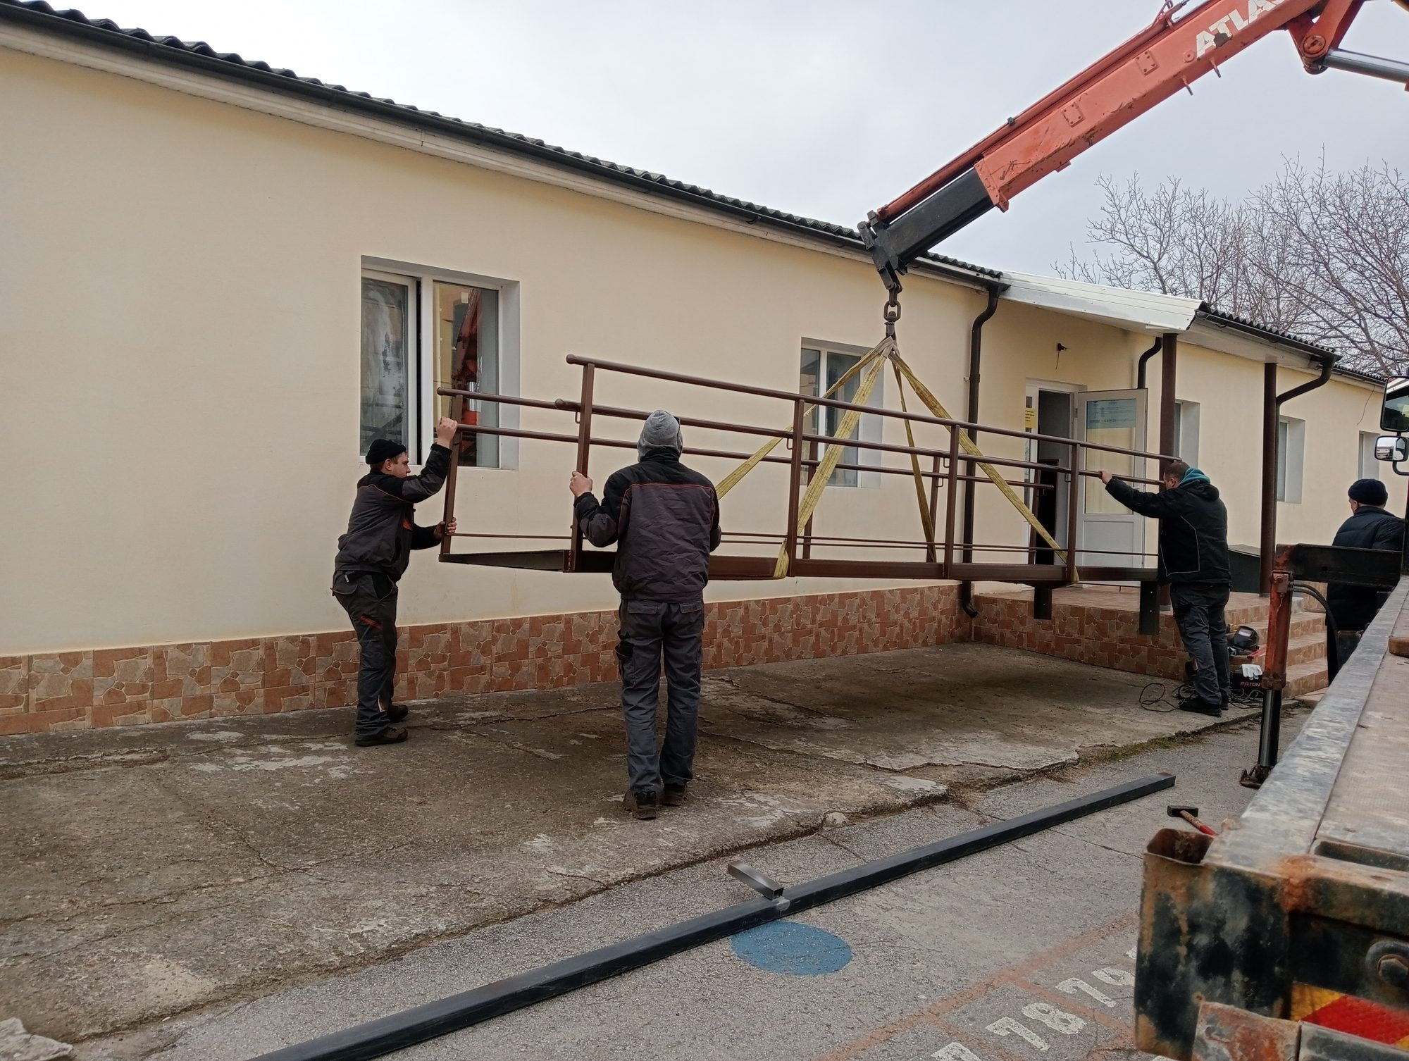
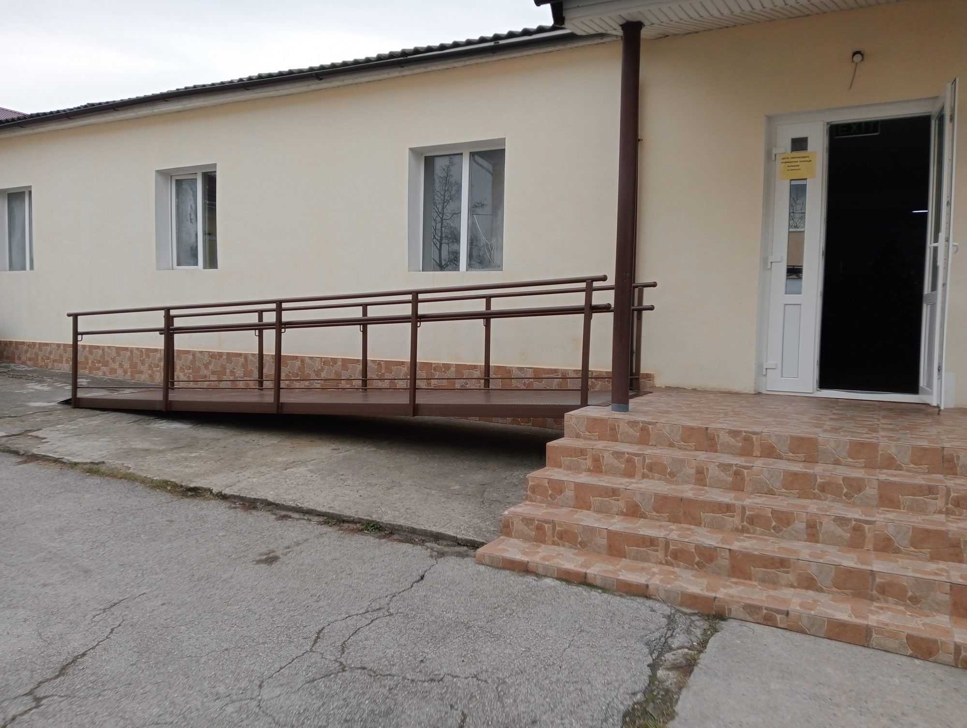
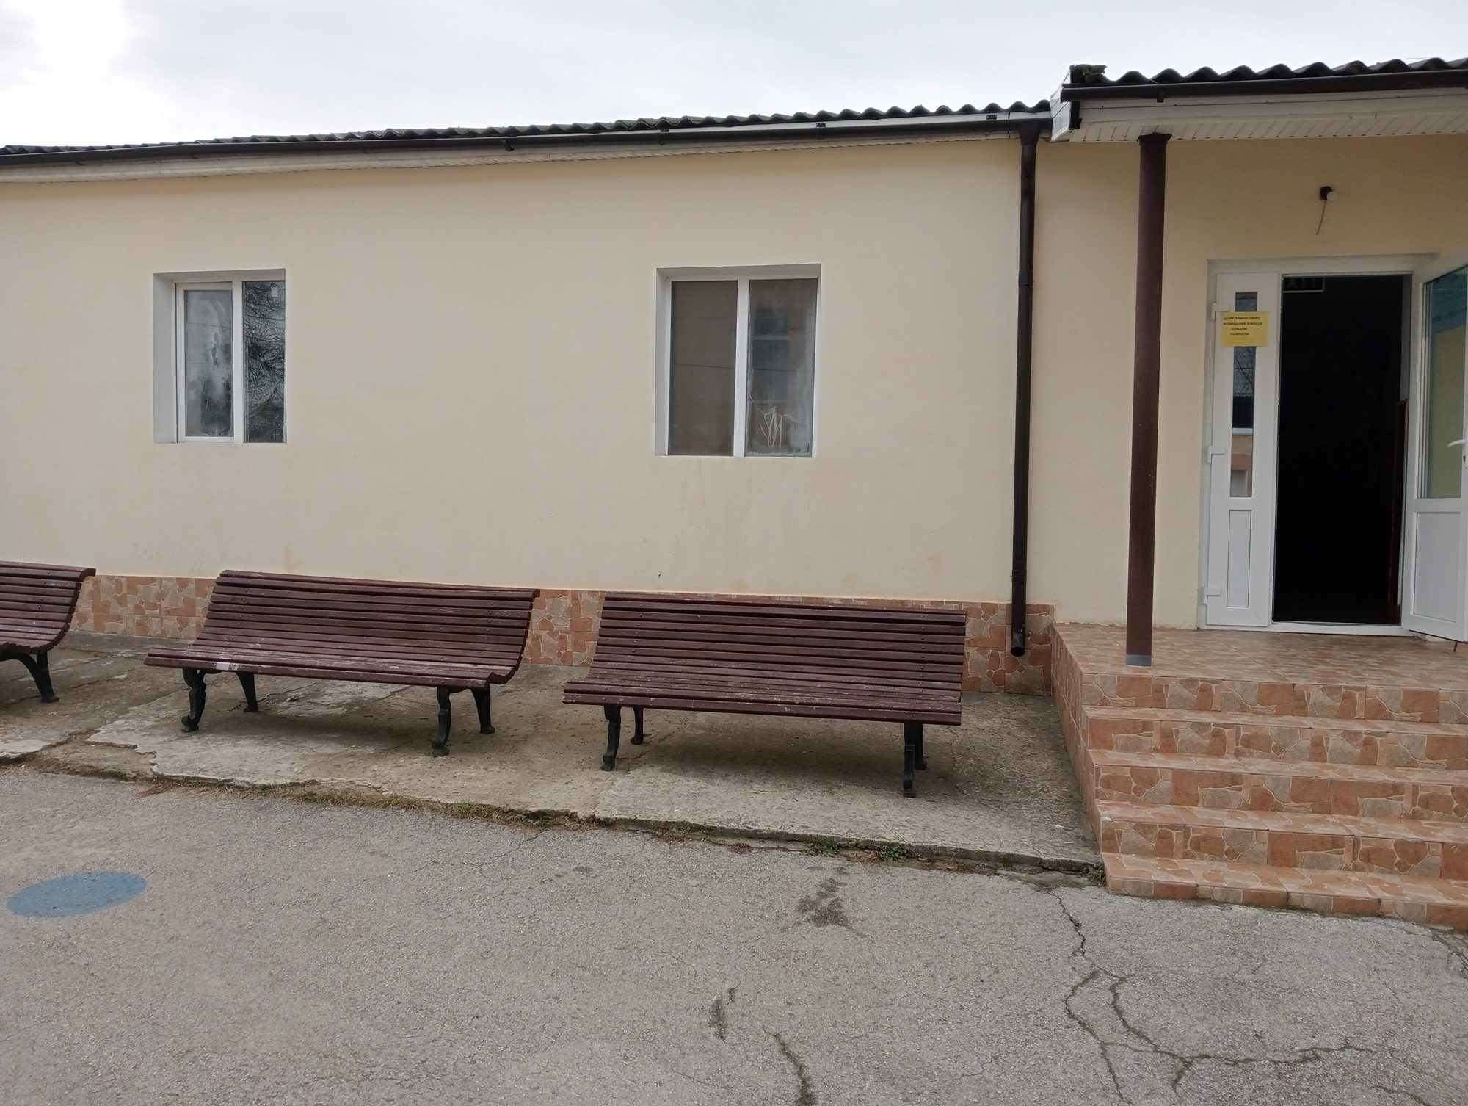

IV: CDPD'S RESPONSE TO THE HUMANITARIAN CRISIS CAUSED BY THE WAR IN UKRAINE.
Adela Goncear , program director
The CRPD, together with other civil society organizations, in 2023, tried to come up with a response to the humanitarian crisis as a result of the war unleashed by the Russian Federation in Ukraine, especially in terms of providing support to refugees, persons with disabilities and their family members. The CRPD's response to the humanitarian crisis referred in particular to:
- Evaluation of temporary accommodation centres for refugees in Ukraine from the perspective of ensuring accessibility conditions, including the services provided to refugees within them.
- Legal advice
- ICLA information, consultation and legal assistance
- Case management
- Individual material aid offered based on the assessment of the individual needs of the beneficiaries.
- Support for the reasonable accommodation of temporary placement centres, including private home owners who practice accommodation for refugees with disabilities.
- Offering food packages specific to individual and hygienic nutrition.
Evaluation of Temporary Accommodation Centres for Refugees in Ukraine
During 2023, 25 temporary placement centres were evaluated.
In addition to the support provided by CDPD through its social enterprise Universal acces SRL, an accessible ramp was built and installed designed to ensure access for people with reduced mobility inside the building of the temporary placement centre for refugees in Bulboaca, Anenii Noi. Reasonable accommodation of 2 private homes where refugees from Ukraine with disabilities are accommodated.
The support provided was for the accessibility of the WC and bathroom rooms, as well as sleeping rooms, by offering multifunctional beds that can be adapted to the individual needs of people with disabilities and electric radiators for heating the rooms during the cold period of the year.
Case management
The house management service was developed for people with disabilities refugees from Ukraine.
Thus, during 2023, the house management service processed and provided assistance for 690 requests from refugees, people with disabilities from Ukraine, of which 487 women and 203 men
Individual material aid for refugees with disabilities from Ukraine (IPA)
The CRPD, during 2023, managed to provide individual material aid to 511 refugees, persons with disabilities, of which 199 men, 312 women. The individual material aid provided by the CRPD consisted of:
- Providing food including special food products (gluten and lactose free).
- Personal hygiene products including adult diapers.
- Orthopaedic shoes.
- Medicines
- Covering the costs of medical investigations and surgeries
- Provision of medical equipment for health monitoring. (Electronic voice tonometers and glucose meters)
- Mobile chairs with toilet for adults, crutches, canes including for the blind as well as walking frame.
- Covering expenses for the processing of passports and consular services
Information, Consultation and Legal Assistance (ICLA)
The CRPD lawyers provided information, consultation and legal assistance services for 783 refugees with disabilities including:
468 people who benefited from information and consultation services
315 people who benefited from Legal Assistance
Information, consultation and legal assistance services were provided in the following areas:
Social protection 230 cases
Healthcare. 329 cases
Medical equipment 79 cases
Temporary protection 375 cases
Inclusive education 26 cases
Employment in the field of work: 51 cases
Legal acts 192 cases
CDPD-080008800 hotline
In order to ensure the access of refugees, persons with disabilities to the services and help offered by the CRPD to refugees, including other organizations that have come up with a response to the humanitarian crisis, the CRPD during 2023 maintained and made available to the beneficiaries the 080008800 hotline through which 2 case managers employed by the CRPD offered assistance to refugees from Monday to Friday between 9.00 and 18.00
Study on Evaluation of the Existing Regulatory Framework on Access to Health Services for Displaced Persons with Disabilities in Ukraine
During 2023, the CRPD conducted research on the evaluation of the existing regulatory framework on access to healthcare services for displaced persons with disabilities in Ukraine
This research aimed to identify the existing gaps in the normative framework of the Republic of Moldova in the field of ensuring the access of displaced persons from Ukraine to healthcare services, in relation to the international standards on access of refugees (in particular, with disabilities) and to the models of good practices applied in neighbouring countries. The conclusions and recommendations developed within the study can be used as benchmarks for identifying solutions to improve the access of displaced persons from Ukraine, especially those with disabilities, to healthcare services, by amending and supplementing the existing regulatory framework.
- ORGANIZATIONAL DEVELOPMENT

Review of internal policies under the CRPD
During 2023, the CRPD Accounting Policy (ANNEX 22) and the personnel policy (ANNEX 23) were revised, new internal documents were developed, in the field of prevention and response to sexual exploitation and abuse (PSEA)
Thus, the following internal documents were developed:

- Policy and procedures for preventing and responding to sexual exploitation and abuse. (Annex 24)
- Staff Code of Conduct. (Annex 25)
- Terms of reference on the role and responsibilities of staff in the field of prevention, exploitation and sexual abuse (Annex 26)
- Policy on protection against acts of retaliation for reporting misconduct or for cooperating in investigations and audits (Annex 27)
- Notification of designation of the PSEA focal point (Annex 28)
- Terms of reference of the PSEA Focal Point for Protection against Sexual Exploitation and Sexual Abuse. (Annex 29)
- Statement of Recognition and Acceptance of Compliance with the Standards of Conduct for Staff and Protection from Sexual Exploitation and Abuse Policies and Procedures (Annex 30)
In addition, recommendations were developed for the modification of the individual employment contracts and service contracts for the personnel employed/contracted by the CDPD under the PSEA aspect
All CRPD employees have completed an online training course in the field of PSEA

CDPD member EDF
In May 2023, the CRPD The General Assembly of the European Forum of Persons with Disabilities EDF awarded the Centre for the Rights of Persons with Disabilities the title of member organisation of the Forum. This result represents a success story of the CRPD as it is the first time that EDF offers membership to a disability organisation that is not part of EU member countries

IMPACT RESULTS 2023

- In the spring of 2023, the Centre for the Rights of Persons with Disabilities (CDPD) became an associate member of the European Disability Forum (EDF). CDPD is the first CSO in the Republic of Moldova to which EDF has offered membership. This allowed EDF to open an exclusive funding program for organizations of persons with disabilities in Moldova because, according to EDF's statute, it can only finance member organizations. Thus, starting with July 1, 2023, EDF funded 4 organizations of persons with disabilities, of which 3 are the local partners IM SDP, the Centre for the Rights of Persons with Disabilities, the Motivation Association of Moldova, the Alliance of Organizations of Persons with Disabilities as well as the Association of the Deaf of the Republic of Moldova. The financial value of the funding program is 600000 Euro, i.e. 150000 Euro for each organization. Duration of the financing 18 months, 01.07.23-31.12.2024. This funding program from EDF is intended for 3 priority areas; providing individual support to people with disabilities; advocacy activities; organizational development.
- As a result of the advocacy campaign carried out by the CDPD and partners over several years, for the first time in the Republic of Moldova, the basic specialized normative act in the field of urban planning, namely the Urban Planning Code of the Republic of Moldova, will contain express provisions regarding: reasonable accommodation; the concept of universal design; people with reduced mobility and other provisions aimed at people with disabilities, especially the accessibility of urban space. We mention that the CDPD initiated the first advocacy actions in order to adjust the Urban Planning Code in accordance with international standards in the field of accessibility in 2015.
- As a result of the advocacy campaign carried out by CDPD and partners, the member organizations of the Civic Platform Chisinau accessible for all, by the decision of the Municipal Council the year 2024 was declared the year " Chisinau Accessible City. " In connection with the declaration of 2024 Chisinau as an accessible city, by the Chisinau City Council in partnership with the organizations of persons with disabilities an action plan was developed "Chisinau accessible city for all" This action plan refers in particular to the following 3 priority areas: accessibility of public institutions; pedestrian paths and pedestrian crossings, as well as accessibility of public transport.
- Persons with disabilities, refugees from Ukraine, as well as citizens of the Republic of Moldova can determine their disability within the National Council for Determining Disability and Work Capacity.
- 20 young people with disabilities improved their quality of life and financial capacity by being employed in the field of snot.
- 3 offices of the Courts of Justice have improved their accessibility conditions, which allows ensuring effective access to justice for people with reduced mobility.
- 24 web portals of the Courts of Justice have improved their web accessibility, which ensures the access of persons with disabilities, especially those with vision as litigants, to the information placed on the web pages of the courts.
- 783 persons with disabilities refugees from Ukraine are informed in the field of the rights of persons with disabilities who are aware of the procedures and what actions they must take to restore the violated right.
- The infrastructure in Chisinau municipality. Chisinau in terms of the accessible arrangement of public spaces (pedestrian paths, pedestrian crossings, traffic lights equipped with sound signalling system, tactile pavement, public transport waiting stations) is more friendly for people with reduced mobility.
- Good practices in arranging accessible and friendly public space are taken over and applied by other local public authorities (Cahul, Ialoveni, Straseni, Ungheni)
- The CDPD General Independent Audit Report 2023 can be viewed by accessing the following link. https://cdpd.md/auditors-report-cdpd-2024/

CRPD 2023 BUDGET
The CDPD in 2023 of the 5th consecutive year for budgeting the expenses established according to the Operational Plan applied the consolidated budget. Thus, the consolidated budget of the CDPD for 2023 constituted: 12488163.47 MDL
 | Donor +RC:R[15]C[7] | Project name | Implementation delay | Approved budget | Opening balance MDL | Income: MDL | Spent until 31.12.2023 for the activities performed: | Current account balance
1 | AO Representative of IM Swedish Development Partner (IM SDP) | Support for CDPD Strategic Plan | 01.01.23-31.12.23 | 820000 SEK | 15724,08 | 1449122,86 | 1464846,94 | 0
2 | European Disability Forum (EDF) | Disability solidarity | 01.01.23-28.02.23 | 8684 EUR | 0 | 178194,81 | 178194,81 | 0
3 | European Disability Forum (EDF) | Ukraine war: OPD led disability inclusive response and recovery (Phase 2) | 01.07.23-31.12.124 | 50000 EUR | 0 | 961250 | 923106,48 | 38143,52
4 | Equal Rights in Action Fund (ERA/NID) | To support local human rights NGOs in their efforts  to achieve safe and secure environments, political participation, and еmроwеrеd and inclusive  movements and organizations" | 01.01.23-31.12.23 | 60000 USD | 0 | 1036316,05 | 1090897,09 | -54581,04
5 | Expert Group Centre for Independent Analysis AO | "Resilient CSOs + Responsible Budgeting = Accelerated Implementation of the Association Agreement" | 01.06.23-31.12.24 | 10000 EUR | 0 | 194250 | 158360,63 | 35889,37
6 | East Europe Foundation (FEE) | Together we develop inclusive employment services for people with disabilities in Chisinau municipality. Chisinau and Criuleni district", | 18.02.23-31.03.24 | 28648.94 EUR | 143235,62 | 413310,66 | 531896,67 | 24649,61
7 | International Organization for Migration (IOM) | "Needs-based support for refugees with disabilities from Ukraine in Moldova" | 01.02.23-30.03.24 | 1447318 CDM | 0 | 1302586 | 1168980,44 | 133605,56
8 | Norwegian Refugee Council (NRC)1 | Improving the protective environment for Ukrainian refugees with disabilities in the Republic of Moldova | 01.10.22-31.01.23 | 75,045.20 EUR | 0 | 851422,08 | 851422,08 | 0
9 | Norwegian Refugee Council (NRC)2 | Strengthening access to legal assistance and information for Ukrainian refugees with disabilities and other vulnerable groups | 01.02.23-14.11.23 | 2141410 CDM | 0 | 1927269 | 2141410 | -214141
10 | United Nation Development Programme (UNDP) 1 | Paradigm Shift to Disability Inclusive Services,  Accountability and Governance in Moldova | 30.03.23-30.09.24 | 55792 USD | 0 | 486376,24 | 323417,36 | 162958,88
11 | United Nations Children’s Fund (UNICEF) | Capacity building of the NCDDWA on the human-rights based approach to disability determination, in alignment with the International Classification of Functioning (ICF), including for children and youth | 05.06.23-30.09.24 | 905171.85 MDL | 0 | 537465 | 251476,61 | 285988,39
12 | United Nation Development Programme (UNDP) 2 | Building sustainable and inclusive peace, strengthening trust and social cohesion in Moldova | 30.11.23-30.07.24 | 1415377 MDL | 0 | 1241870 | 44447,75 | 1197422,25
13 | SOROS Foundation Moldova | "Strengthening the "Accessible Chisinau" Platform – stage 5" | 01.01.2023 - 29.12.2023 | 60000 USD | 0 | 1112569 | 1112569 | 0
14 | Dexis Interactive Incorporated Washington Chisinau Branch | Access to Justice | 01.01.23-31.12.23 |  |  | 480658,25 | 480658,25 | 0
15 | World HEALTH ORGANIZATION-(WHO) | Access to refugee medical services | 01.01.23-31.12.23 |  |  | 179556,52 | 0 | 179556,52

https://cdpd.md/raport-privind-realizarea-auditului-accesibilitatii-cladirea-ministerului-justitiei/
https://cdpd.md/raport-evaluarea-accesibilitatii-paginilor-web-ale-instantelor-si-autoritatilor-judiciare/
https://aaij.justice.md/
https://oatucl.md/ghiseul_unic
https://actelocale.gov.md/ral/act/cu-privire-la-declararea-anului-2024-anul-accesibilit%C4%83%C8%9Bii-%C3%AEn-municipiul-chi%C8%99in%C4%83u-1372178.html
https://www.mc.gov.md/ro/content/institutiile-de-cultura-vor-fi-evaluate-sub-aspectul-accesibilitatii-persoanelor-cu-nevoi
https://cdpd.md/evaluarea-accesibilitatii-programelor-educationale-si-mijloacelor-asistive-in-institutiile-de-invatamant-profesional-tehnic/
https://cdpd.md/raport-de-evaluarea-serviciilor-anofm/
https://cdpd.md/studiu-evaluarea-cadrului-de-reglementare-existent-privind-accesul-la-serviciile-medicale-pentru-persoanele-cu-dizabilitati-stramutate-din-ucraina

